OFFICE CHAIR | MANUFACTURER | MODEL NO. | DESCRIPTIONS | PICTURES
FOR SHERIFF USE ONLY | Office Master | - Weight Capacity - 350 lbs.  - IU76PD - JR-BN  - IU79PD - JR-BN  - Weight Capacity - 400 lbs.  - MX84PD - JR-BN  - MX84IU -JR-BN | - Seat Depth: 18” – 20.5”  Seat Width: 22”  Seat Height: 17” – 22”  Back Adjustability: 4”  Back Height: 22”  Back Width: 22”  For intensive use applications that require an extra measure of toughness and reliability. Built with a heavy-duty structure and upholstered with memory foam in the seat and in fabrics that feature high double-rub count.  Arm rests – JR-BM = Height adjustable T arms with fold-back feature with ballistic nylon upholstered arm pads.  - Seat Depth: 18” – 21.1”  Seat Width: 22”  Seat Height: 17” – 22”  Back Adjustability: 4”  Back Height: 28”  Back Width: 19.5”  Warranty: 7 years | 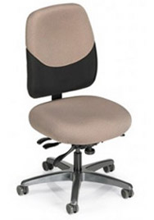
Petite | Office Master | Paramount  PT69-KR-200 | Seat Depth: 16.5 - 19”  Seat Width: 19”  Seat Height: 17” – 22”  Back Adjustability: 3”  Back Height: 22”  Back Width: 17”  Arm Width (horizontal - in & out adjustment): 1” per side only KR 200 (JR 77 doesn’t adjust horizontally)  Arm Height (vertical – up & down adjustment): KR 200 – 2.75 or JR 77 – 4.25”  Weight Capacity: 300 lbs  Warranty: 12 years | 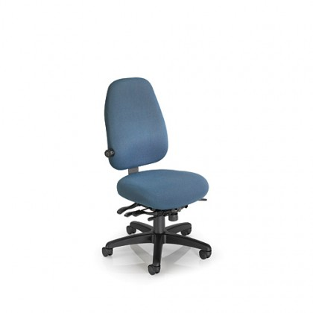
Petite | Sitmatic | GoodFit  GU22 SE SH10 NC + 1A (with Nano Cylinder) | Seat Depth: 17.0” – 19.50”  Seat Width: 19.0”  Seat Height: 15” – 17.75”  Back Adjustability: 6”  Back Height: 21”  Back Width: 18”  Weight Capacity: 300 lbs.  Warranty: 10 years | 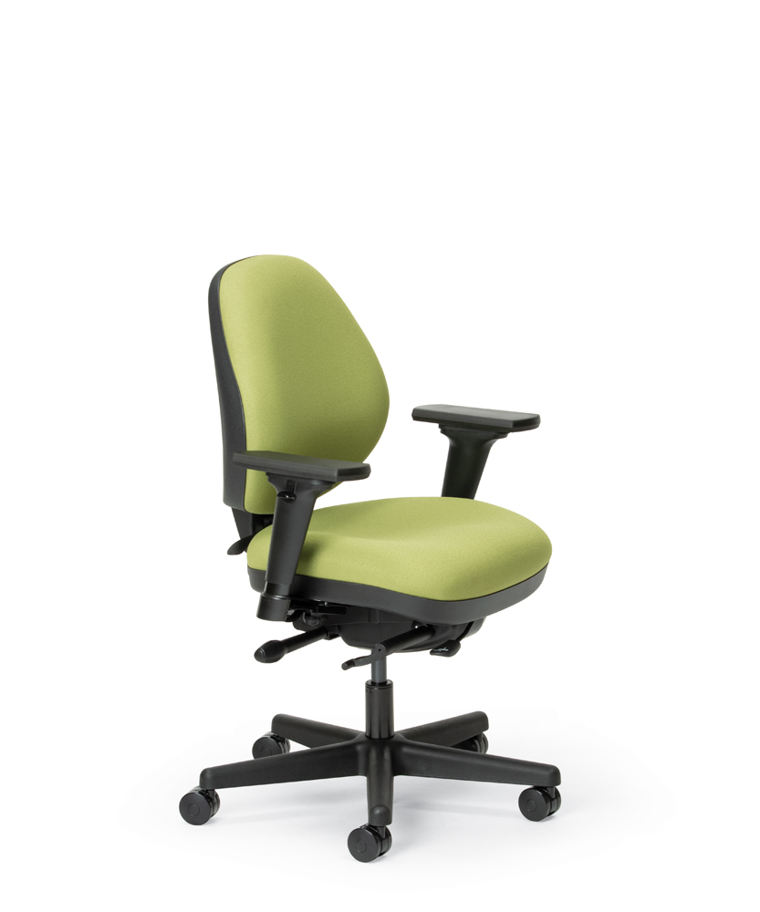
Petite | RFM | Trademark 2515-480-13B-65MM-23A | Seat Depth: 17.5”  Seat Width: 18.5”  Seat Height : 18” – 20.5”  Back Adjustability: 3.5”  Back Height: 20.0”  Back Width: 19.0”  Arm Width (horizontal - in & out adjustment)  Arm Height (vertical – up & down adjustment): 08A : 3”  Weight Capacity: 300 lbs.  Warranty: 12 years | 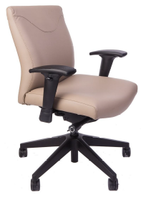
Petite  NOTE: Adjustable air  lumbar for upper and lower back. | RFM | Evolve 1535-23A-480S-13B-65MM-68L | Seat Depth: 17.5”  Seat Width: 18.5”  Seat Height: 17.27” – 19.75”  Back Adjustability: 3”  Back Height: 23.5”  Back Width: 19.0”  Weight Capacity: 300 lbs.  Warranty: 12 years | 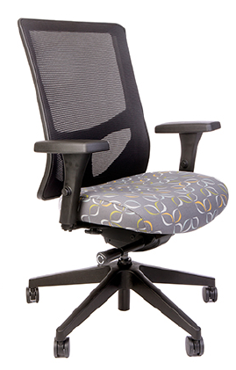
Petite - Wide | Office Master | PT 74-KR200 | Seat Depth: 17.0 - 19.5”  Seat Width: 20”  Seat Height: 17.0 – 22.0”  Back Adjustability: 3”  Back Height: 18.0”  Back Width: 17.0”  Weight Capacity: 300 lbs.  Warranty : 12 year limited | 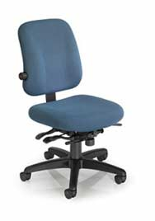
Petite - Wide | Sitmatic | GoodFit  GU23 SE SH20 + 1A | Seat Depth: 17.0" to 19.5"  Seat Width: 21.0”  Back Height: 16.75” – 20.25”  Backrest Adjustability: 6"  Back Height: 21.0”  Back Width: 18.0”  Weight capacity: 300lbs  Warranty: 10 years | 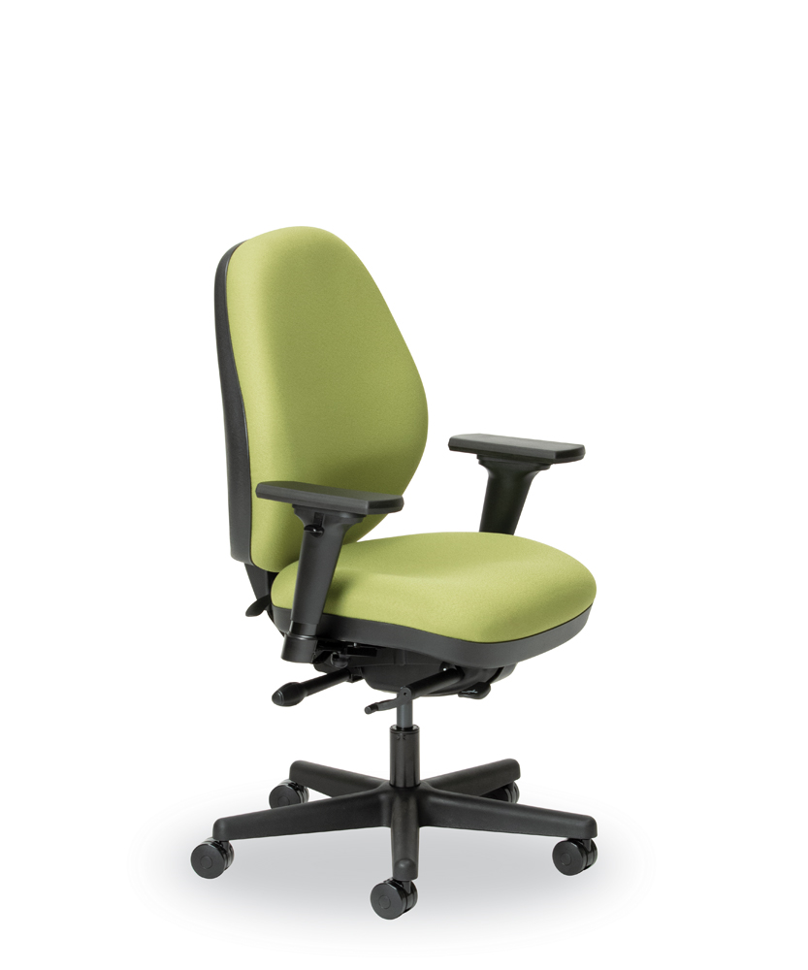
Petite - Wide | RFM | Trademark 2515-422-23A | Seat Depth: 17.5”  Seat Width: 20.5”  Seat Height: 18.5” – 21.75”  Back Adjustability: 3.5”  Back Height: 20”  Back Width: 19”  Arm Width (horizontal - in & out adjustment): 1” per side only KR 200 (JR 77 doesn’t adjust horizontally)  Arm Height (vertical – up & down adjustment): KR 200 – 2.75”, JR 77 - 4.25”  Weight Capacity: 300 lbs.  Warranty : 12 year limited | 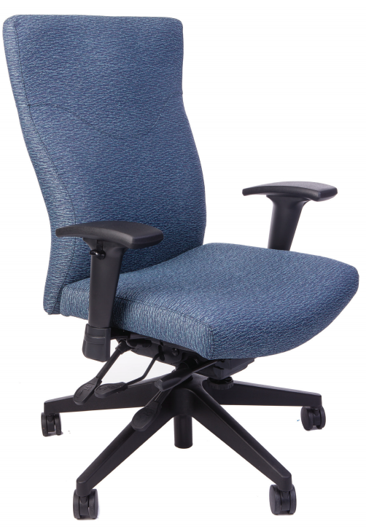
Standard | Office Master | Paramount  PT78-KR-200 | Seat Depth: 18 – 20.5”  Seat Width: 21”  Seat Height: 17 – 22”  Back Adjustability: 4”  Back Height: 22”  Back Width: 19.5”  Arm Width (horizontal - in & out adjustment): 1” per side only KR 200 (JR 77 doesn’t adjust horizontally)  Arm Height (vertical – up & down adjustment): KR 200 – 2.75”, JR 77 - 4.25”  Weight Capacity: 300 lbs.  Warranty : 12 year limited | 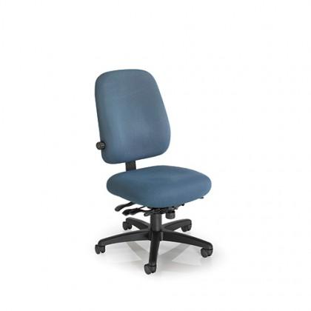
Standard | SItmatic | GU33 SE + 1A | Seat Depth: 19.0” – 21.5”  Seat Width: 21.0”  Seat Height: 16.75” – 20.25”  Back Adjustability: 6”  Back Height: 23.0”  Back Width: 19”  Weight Capacity: 300 lbs.  Warranty : 10 years | 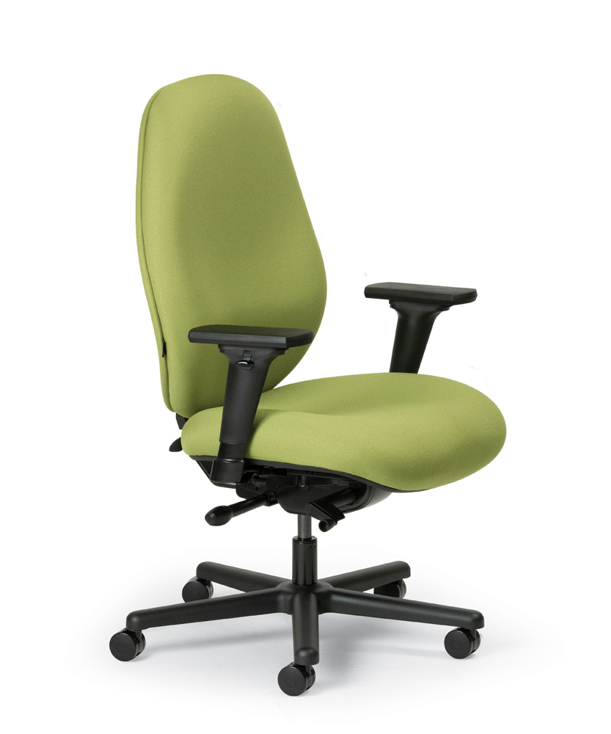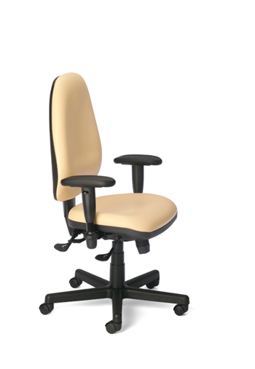
Standard | RFM | Trademark 2535-23A | Seat Depth: 19”  Seat Width: 20”  Seat Height: 18.5” – 21.50”  Back Adjustability: 3.5”  Back Height: 24”  Back Width: 19”  Weight Capacity: 300 lbs.  Warranty : 12 years | 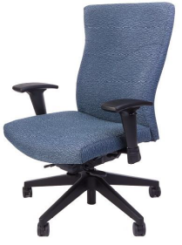
Standard  NOTE: Adjustable air  lumbar for upper and lower back. | RFM | Evolve 1535-D-23A-68L | Seat Depth: 17.5”  Seat Width: 18.5”  Seat Height: 18.5” – 21.75”  Back Adjustability: 3.5”  Back Height: 23.5”  Back Width: 19”  Weight Capacity: 300 lbs.  Warranty: 12 years
Slim/Tall  NOTE: Chair is made for an employee that is over 6’3” tall. | Office Master | PT79-KR300 | Seat Depth: 21.5” – 24.6”  Seat Width: 23.5”  Seat Height: 19” - 25”  Back Adjustability: 4”  Back Height: 28”  Back Width: 19.5”  Arm Width (horizontal - in & out adjustment): 1” per side only KR 200 (JR 77 doesn’t adjust horizontally)  Arm Height (vertical – up & down adjustment): KR 200 – 2.75”, JR 77 - 4.25”  Weight Capacity: 300 lbs.  Warranty : 12 years | 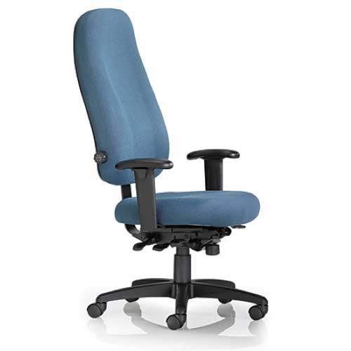
Slim/Tall  NOTE: Adjustable air  lumbar for upper and lower back. | RFM | Trademark 2535-899  NOTE: Chair is made for an employee that is over 6’3”. | Seat Depth: 19”  Seat Width: 20”  Seat Height: 18.5” – 21.75”  Back Adjustability: 3.5”  Back Height: 24”  Back Width: 19”  Weight Capacity: 300 lbs.  Warranty : 12 years | 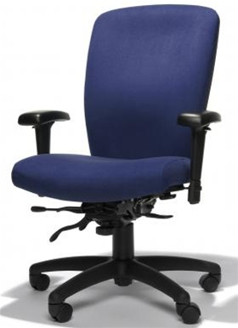
Slim/Tall | Sitmatic | 381 SY XC + 1A  Boss Task  NOTE: Chair is made for an employee that is over 6’3”. | Seat Depth: 21” – 23.5”  Seat Width: 21”  Seat Height: 18” – 25”  Back Adjustability: 6”  Back Height: 22.75”  Back Width: 19.5”  Arm Width (horizontal - in & out adjustment): 2” range per side for +1N armrest option (width adjusts by fingertip lever; 6 positions; 10” long by 4”)  Arm Height (vertical – up & down adjustment): 4” range for 1N armrest option (height adjusts by fingertip lever; 10 positions; 10” long by 4”)  Weight Capacity: 400 lbs.  Warranty : 10 years | 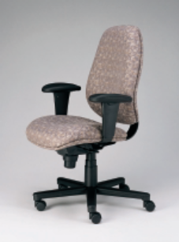
Heavy/Wide | Office Master | MXIU 84  (petite backrest) | Seat Depth: 17” – 19.5”  Seat Width: 24”  Seat Height: 18” – 23”  Back Adjustability: 4”  Back Height: 20”  Back Width: 23.5”  Arm Width (horizontal - in & out adjustment): 1” per side only KR 200 (JR 77 doesn’t adjust horizontally)  Arm Height (vertical – up & down adjustment): KR 200 – 2.75”, JR 77 - 4.25”  Cylinder:  Weight Capacity: 400 lbs.  Warranty : 12 years | 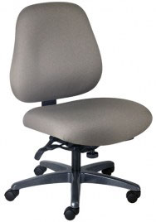
Heavy/Wide | Office Master | MXIU 88  (standard backrest) | Seat Depth: 17” – 19.5”  Seat Width: 24”  Seat Height: 18” – 23”  Back Adjustability: 4”  Back Height: 25”  Back Width: 23.5”  Arm Width (horizontal - in & out adjustment): 1” per side only KR 200 (JR 77 doesn’t adjust horizontally)  Arm Height (vertical – up & down adjustment): KR 200 – 2.75”, JR 77 - 4.25”  Cylinder:  Weight Capacity: 400 lbs.  Warranty : 12 years | 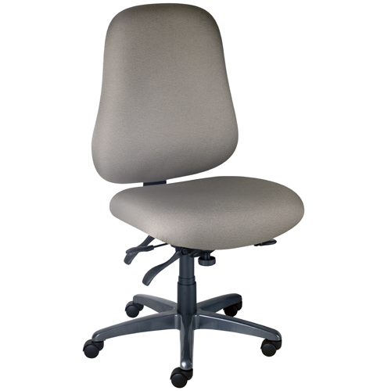
Heavy/Wide | Sitmatic | GoodFit Plus Size Chair  GU44 SY + 1A | Seat Depth: 22.0” – 24.5”  Seat Width: 24”  Seat Height: 16.75 – 20.25”  Back Adjustability: 6”  Back Height: 23.0”  Back Width: 21.0”  Arm Width (horizontal - in & out adjustment): 2” range per side for +1N armrest option (width adjusts by fingertip lever; 6 positions; 10” long by 4”)  Arm Height (vertical – up & down adjustment): 4” range for 1N armrest option (height adjusts by fingertip lever; 10 positions; 10” long by 4”)  Weight Capacity: 400 lbs.  Warranty : 10 years
Heavy/Wide | RFM | Trademark BT28 | Seat Depth: 20”  Seat Width: 24”  Seat Height: 18.5” – 22”  Back Adjustability: 4”  Back Height: 24”  Back Width: 19”  Weight Capacity: 500 lbs.  Warranty : 12 years | 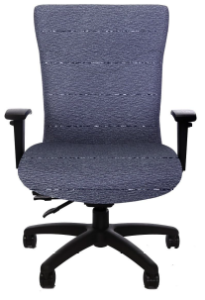
Heavy/Wide | RFM | Evolve BT16-2004-25A-60L | Seat Depth: 22”  Seat Width: 24”  Seat Height: 19.25” – 22.75”  Back Adjustability: 2.75”  Back Height: 19.5”  Back Width: 18.5”  Weight Capacity: 400 lbs.  Warranty : 12 years | 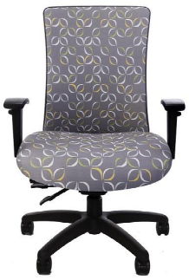
Stool | Sitmatic | GoodFit  GU13 OT SS TK + 1N | Seat Depth: 19.0” – 21.5”  Seat Width: 21.0”  Seat Height: 24.5” – 34.0”  Back Adjustability: 6”  Back Height: 17.0”  Back Width: 17.0”  Weight Capacity: 300 lbs.  Warranty : 10 years | 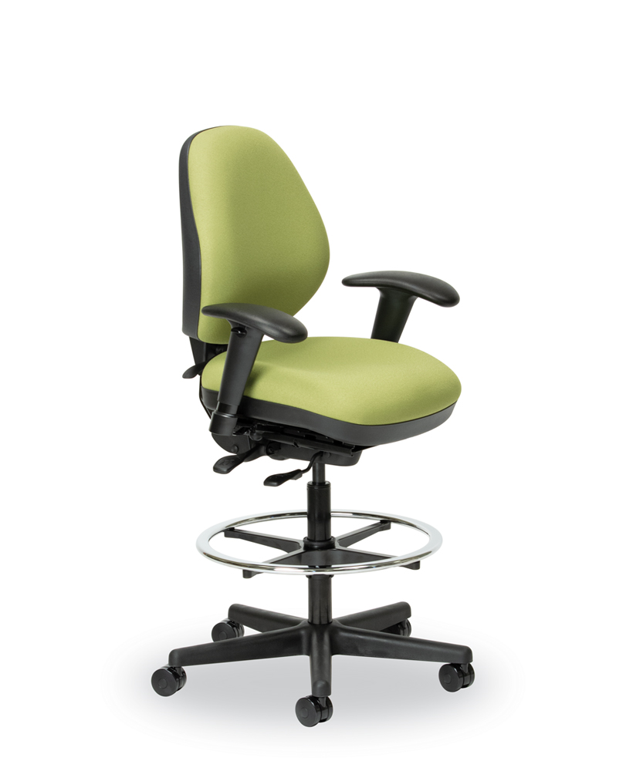

Executive Chair | RFM | - PETITE:  4515 Medium Managers Chair  25” resin base.  - STANDARD:  4585  Executive High Back Chair  27” resin base. | - Seat Depth: 18.5” – 20.5”  Seat Width: 19.5”  Seat Height: 19.6” – 23”  Back Adjustability: 4”  Back Height: 22.75”  Back Width: 20.25”  Arm Width (horizontal - in & out adjustment):  Arm Height (vertical – up & down adjustment):  - Seat Depth: 20” – 22”  Seat Width: 21”  Seat Height: 19.5” – 22.75”  Back Adjustability: 4”  Back Height: 30”  Back Width: 22”  Arm Width (horizontal - in & out adjustment):  Arm Height (vertical – up & down adjustment):  Weight Capacity: 300 lbs.  Warranty : 10 years | 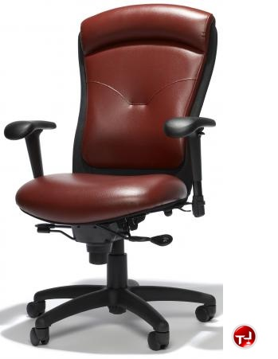

Keyboard Tray |  | Humanscale- Combo Platform |  | 6G10090F22 |  | Combo Platform with 9”Clip Mouse with synthetic leather foam with 22” track. |  | 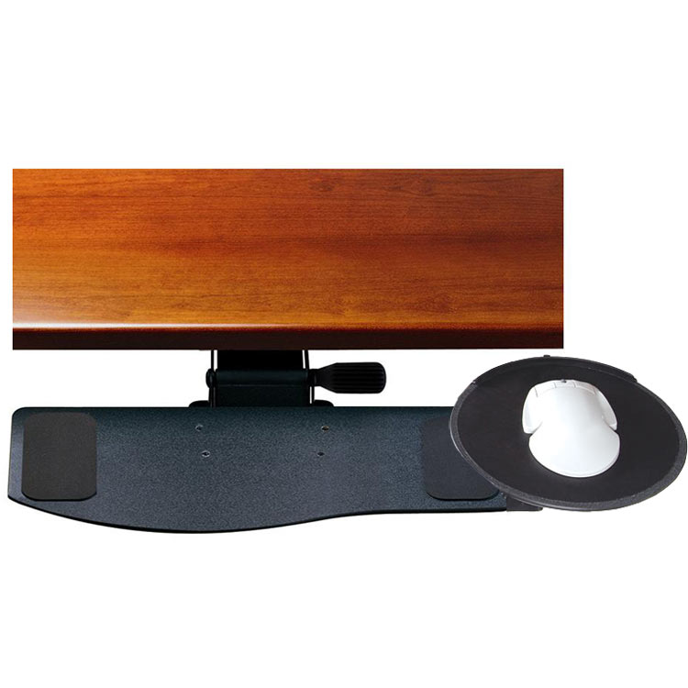
Keyboard Tray |  | Humanscale |  | 6G550F22 |  | Height adjustment range is 7” and comes with synthetic foam wrist rest. 550 tray is designed to keep both mouse and keyboard on same surface allowing closer reach to mouse. |  | 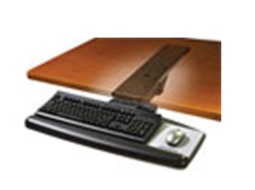  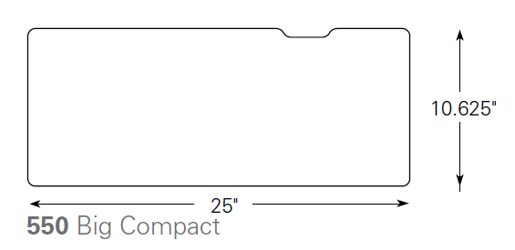
Keyboard Tray |  | Workrite |  | Platform  Banana-Board Platform  #2180S  Track  Pinnacle 2-VALUE  3175-22NB (22” track)  3175-17NB (17” track) |  | - Injection molded plastic platform includes a document holder and cable management system  - Adjustable mouse platform is constructed from ultra-think phenolic materials and slides easily from side to side for both left or right handed users  - Removable memory foam palm support  - Platform requires radius or diagonal of 12” or more for proper installation and use |  | 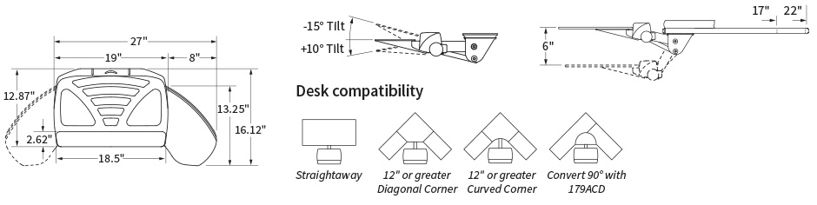
Keyboard Tray |  | Workrite |  | Platform  Microsoft Natural Banana-Board Keyboard Tray – 2181SN  Track  Pinnacle 2-VALUE  3175-22NB (22” track)  3175-17NB (17” track) |  | - Ultra-thin phenolic platform design is contoured to accommodate the Microsoft Natural Keyboard and includes our Optimizer document holder and cable management system  - Adjustable mouse platform slides easily from side to side for both left or right handed users  - Platform requires radius or diagonal of 12” or more for proper installation and use |  | 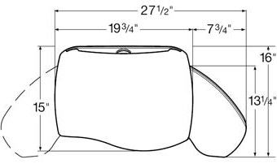
Keyboard Tray |  | Workrite |  | Platform  Revo  2227-17 (17” track length)  2227-22 (22” track length)  Track  Pinnacle 2-VALUE  3175-22NB (22” track)  3175-17NB (17” track) |  | The Revo System features a versatile Mouse-Over platform designed for use in mouse intensive or limited reach applications and is a good solution for straight or corner workspace applications.  Revo is available as a solo platform or as part of a complete system that includes our Pinnacle 2 keyboard arm with maintenance-free 17” or 22” ball bearing track. The platform is constructed from durable ultra-thin phenolic and features a built-in document holder and cable manager.  - Includes Optimizer document holder & cable management  - UltraThin™ .25″ solid phenolic construction  - Removable memory foam palm support |  | 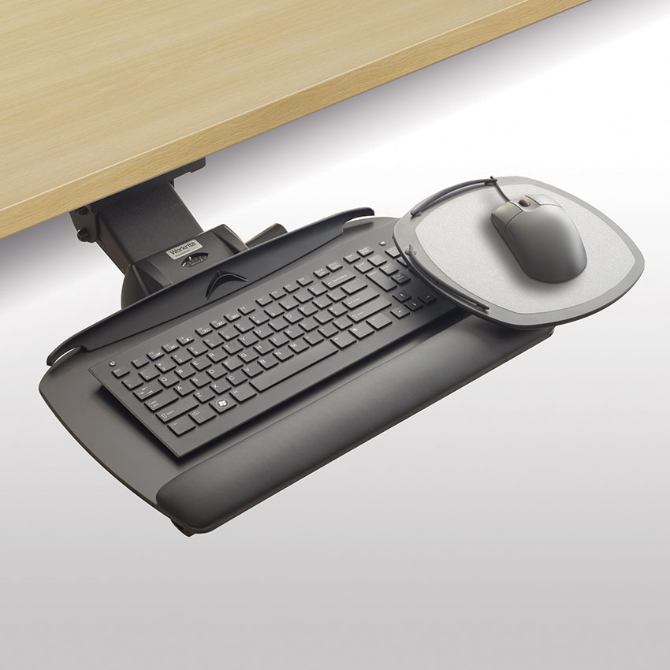  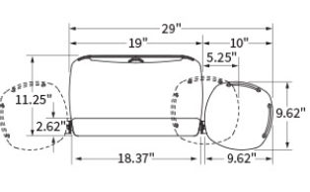
Keyboard Tray |  | Grand Stands |  | 15810K-1  20”x10” Platform with 9” Flexmouse Tray |  | - 1/4 “ thick life-time material  - Non-skid pads, wire mouse guard and microfilm mousing surface. Adjustable flex mouse platform for multiple way use; left and right handed option available. |  | 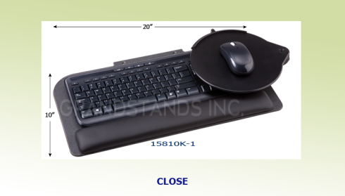
Document Holder |  | Workrite |  | 2560 |  | - Places documents directly in-line with the monitor; reducing bending and twisting of neck and shoulders  - Made with 1/4" ultra-thin composite plastic  - Slotted style angle adjustment lets you instantly change angle from 42° to 82°  - 5 3/8" height adjustability allows document holder to drop over front edge of work surface so that documents do not block view of the monitor  - Available in two sizes: 11 3/4" wide and 17 3/4" wide  - Color: black  - Dimensions: 11 3/4" or 17 3/4" wide x 9 1/2" deep x 11 1/2" high |  | 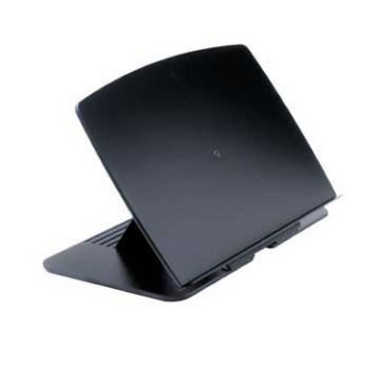
Document Holder |  | 3M |  | DH640 – In-line Document Holder |  | - Height and angle adjustable document holder places documents in-line with your monitor and keyboard reducing movement of eyes, neck and shoulders minimizing strain and increasing comfort  - The stable weighted base allows ledge to dip below the desk edge increasing desk space  - Elastic line guide marks you place, keeps pages open and stretches to accommodate even the thickest books  - The 18" wide backplate and 300 sheet capacity supports books, catalogs and just about any size document |  | 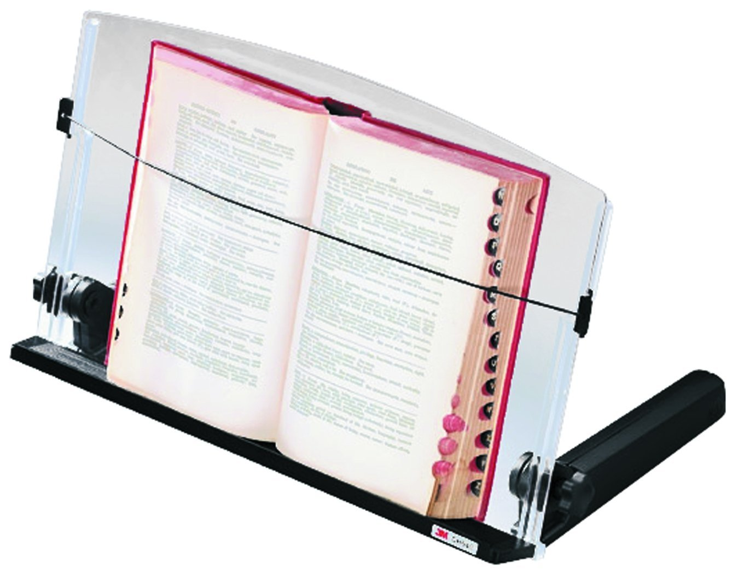
Footrest |  | 3M |  | FR330 |  | - Adjustable tilt & height  - Heavy-duty steel  - 4"H x 18"W x 13"D  - Contoured "non-skid" foot platform designed for maximum comfort |  | 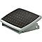
Keyboard |  | Microsoft |  | Natural Ergonomic Keyboard Sculpt Comfort  Wireless keyboard |  | - Contoured for comfort – Contoured design promotes a natural wrist position and puts keys with easy reach.  - Detachable palm rest - Detachable palm rest can be removed for a sleek, compact look. Work in the position that's most comfortable for you with detachable palm rest and adjustable keyboard legs.  - Split spacebar with backspace functionality - Split spacebar with backspace functionality is designed to improve typing efficiency.  - Four-way scrolling - Scroll left, right, front and back. Quickly navigate all of your projects with speed and efficiency.  - Customizable Windows touch tab  Product Dimensions: 17.8” L x 8.39” W |  | 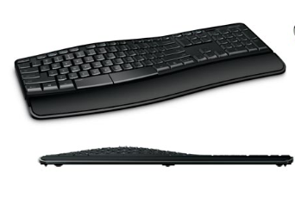
Keyboard |  | Logitech |  | K 350 2.4 Ghz Wireless keyboard |  | - Wave design with Constant Curve layout: Curved layout guides hands into just the right position  - Ease and comfort: Cushioned palm rest makes work easier and fun more fun  - Longer battery time: This feature gives you up to three years of battery life. (Battery life based on a calculation of an estimated 2 million keystrokes per year in an office environment. User experience may vary.)  - Logitech Unifying receiver: The tiny Unifying receiver stays in your notebook, so there's no need to unplug it when you move around. And you can easily add compatible wireless mice and keyboards to the same wireless receiver  Product Dimensions: 18.9 x 9.9 x 2.9 inches ; 3.3 pounds |  | 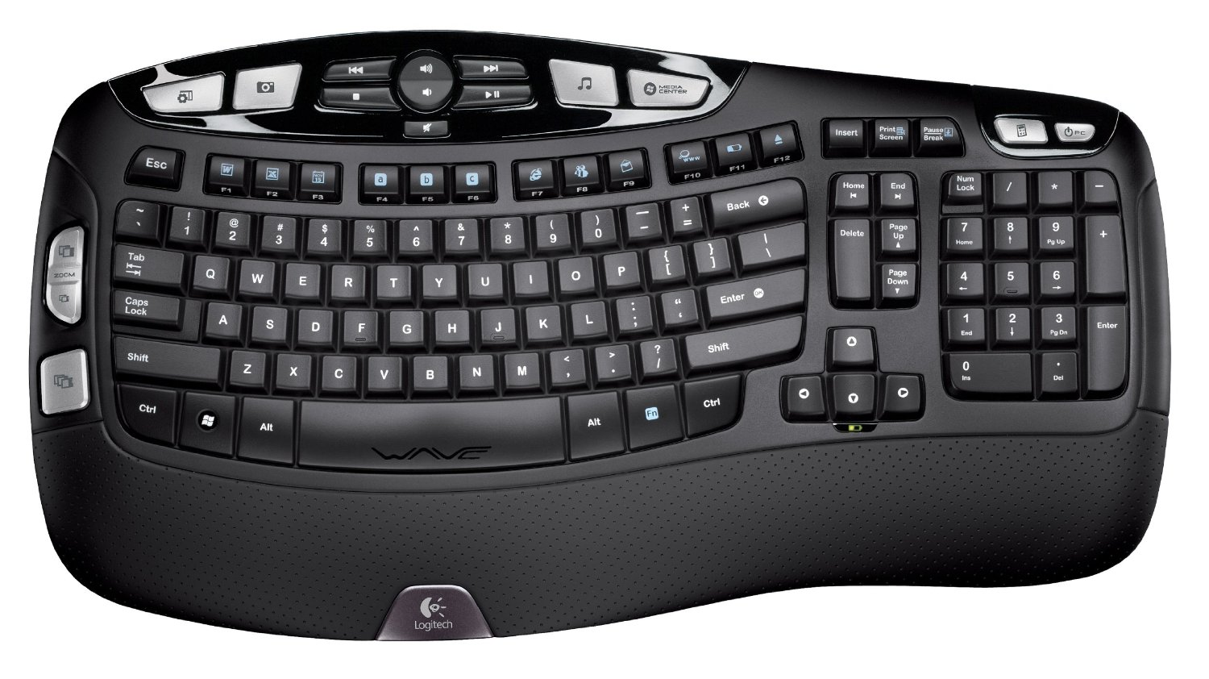
Keyboard |  | Kensington |  | Comfort Type  Wired keyboard |  | - Comfort Type key structure for maximum productivity  - Unique key shape compliments natural typing for increased comfort  - Full size keyboard built for the touch typist  - Reliable plug-and-play operation with wired USB connection  - Built to last with a limited lifetime warranty  - Black keyboard with 104-key layout  Product Dimensions: 18.75 x 7.5 X 1 inches |  | 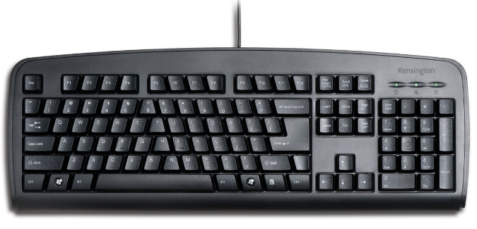
Keyboard |  | Evoluent |  | Reduced Reach Keyboard – R3K  Wired keyboard |  | - ▪ Eliminates stretching your arm to reach the mouse by having the numeric keypad on the left.  - Your mouse may be much closer on the right.  - Allows your right arm to be in a relaxed neutral position when using the mouse.  - Reduces the need to remove your hand from the mouse by allowing your left hand to operate Enter, Del, Page Up, Page Down, arrows, and other keys in the numeric keypad on the left.  - Duplicate Page Up, Page Down, Home, End, Del, and arrow keys on the right.  - Full size arrows, Del, F’s, Ctrl, and Alt keys for easy operation.  - Extra Del key at the left end of the spacebar allows left hand operation so you can keep your right hand on the mouse.  - Tactile bumps on often used keys such as Del, End, Page Down, Ctrl, and down arrow to aid operation by touch.  - Hot keys for one touch access to the Internet, e-mail, media player, volume control, standby, power off, and other functions.  - High quality, notebook computer-type key mechanisms with precision feel.  - Only 1/2 inch or 12.5 mm thick overall with ultra flat key caps.  Product Dimensions: 15.4” wide, 6.25” deep, 0.5” thick |  | 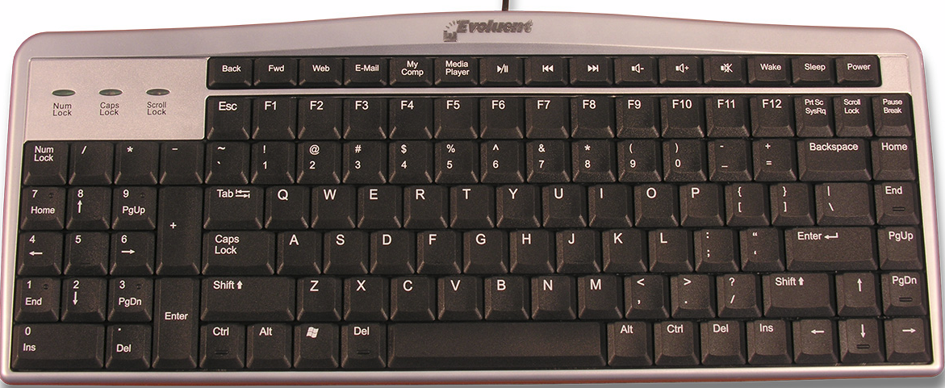
Keyboard |  | Goldtouch |  | GTS-0077 Goldtouch Ergosecure SC2.0 Black |  | - Easily adjusted, locking ball and socket latch mechanism  - Standard alphanumeric key layout (Qwerty)  - Adjustment for wrist splay in horizontal plane from 0° to 30°, continuously variable  - Adjustment for wrist pronation - vertical tenting from 0° to 30°, continuously variable  - Embedded, built-in numeric keyboard activated by function lock  - Full size, full travel, tactile feedback keys with soft end-stop  - Low noise key actuation  - Large space bars for easy thumb use  - Dimensions: 15 1/4" wide x 7" deep x 1" high  - Available Colors: White and Black |  | 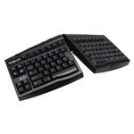
Keyboard (portable) |  | Goldtouch |  | Goldtouch Go!2 Bluetooth Wireless Mobile Keyboard |  | - Combine the portability and comfort of a fully ergonomic Goldtouch mobile keyboard with the best in Bluetooth technology, and what do you get? The elegant Go!2 Bluetooth Wireless Mobile Keyboard. With full-sized keys and all the benefits of Bluetooth technology, the Wireless Mobile Keyboard is truly the perfect companion for the on-the-go worker.  - Enjoy patented Goldtouch comfort: With our patented lock and lever system, find perfect fit with adjustments from 0º to 30º along the horizontal plane and 0º to 30º along the vertical plane.  - No cord catches or tangles: Bluetooth technology will sync this cordless keyboard with all your mobile devices.  - Goes where you do: Light, slim, and easy to fold, the Go!2 Bluetooth Wireless Mobile Keyboard is as portable as any of your mobile devices.  - Take advantage of driver-free installations: The Goldtouch Go!2 Bluetooth Wireless Mobile Keyboard is compatible with Windows 7, 8, 10, Vista, XP, and 2000, and Mac 10.4 and above. Just pair and play! Additionally, this keyboard has multimedia key support for both Windows and Mac OS.  Dimensions: Width: 13.5 inches, Depth (front-to-back): 6 inches, Height .9 inches |  | 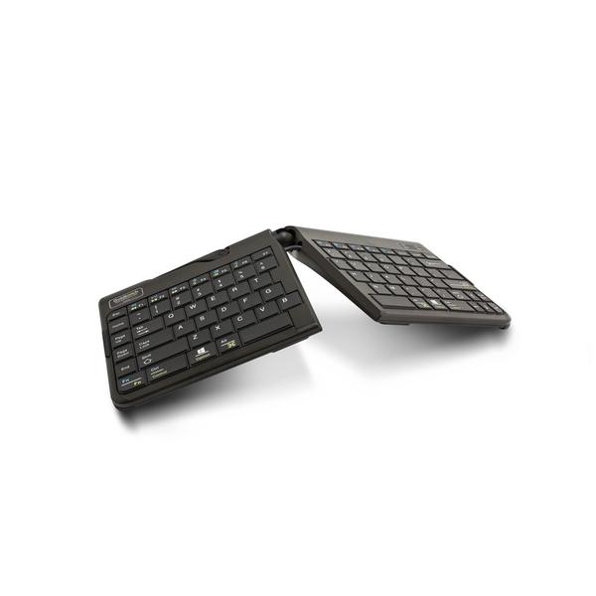
Numeric Keypad |  | Goldtouch |  | GTC-0077 - Goldtouch Numeric Pad, USB Black  (To be paired with the Goldtouch Keyboard) |  | - Allows you to do all your calculations from the keypad; errors are reduced, and efficiency is enhanced  - Keyboard plugs directly into USB port in numeric keypad  - The keypad has all the functions that will make you work efficiently in Excel spreadsheets by providing easy access to essential keys such as:  - Tab, Escape, Backspace and also frequently needed symbols.  - Calculator functions such as: MS M+ MC MR will make the use of MS calculator much easier as will the Clear (Esc) CE (Del) Backspace +/- and =  - Dimensions: 6" length x 3-3/4" wide x 1" high |  | 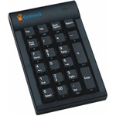
Keyboard |  | BakkerElkhuizen |  | UltraBoard 950  Wireless Compact Keyboard |  | - BakkerElkhuizen UltraBoard 950 Wireless Compact Keyboard (US)  Features:  - Has rechargeable batteries and works with both Windows and macOS.  - Because of its compact form you will adopt a better work posture,  resulting in fewer forearm problems.  - The UltraBoard 950 Wireless has a modern and stylish design.  - A compact keyboard without the numeric keypad, which allows placing  the mouse closer to the keyboard.  Dimensions: 11.22"W x 0.75"H x 5.79"D |  | 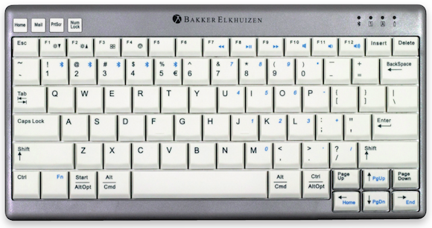
Numeric Keypad |  | BakkerElkhuizen |  | S-Board 840 Design Numeric Keypad  (To be paired with the UltraBoard 950 Wireless Compact Keyboard) |  | The BakkerElkhuizen S-board 840 Numeric Keypad is the ideal solution for anyone who has the S-Board 840 keyboard or any true ergonomic keyboard. The advantage of this high-quality, compact, lightweight keypad is that it can be placed anywhere on the desk, so you can choose the most relaxed posture for your own shoulders. May of course be used on the left.  This numeric-keypad is USB compatible and has a built-in calculator function! The number pad has 26 different keys.  This small, portable number-pad is perfect for use with a laptop as well. The shorter distance from the mouse to the keyboard helps reduce RSI.  - Design fits: with the S-board 840 compact keyboard.  - Including: hand-held calculator functionality.  - Smart: extendable USB cable.  - Quality: comfortable typing (shear mechanism instead of membranes).  - Unique: 26 different keys on one number pad.  - Connection: USB.  - Dimensions: 0.82"H x 3.75"W |  | 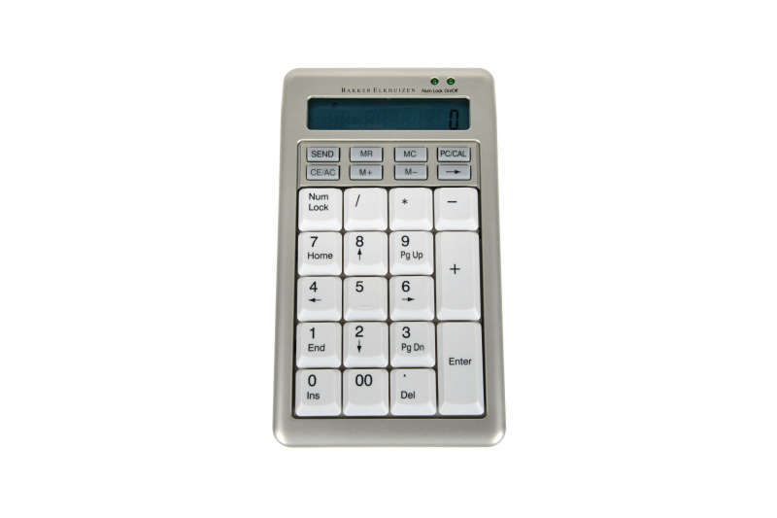
Keyboard (portable) |  | Posturite |  | 9820010 |  | - Compact slimline profile - perfect for mobile workstations  - Ergonomic benefits - reduce risk of overreaching  - Slide-out number pad - there when you need it, concealed when you don’t  - PROTX2™ antimicrobial protection built in  - Shortcut function keys for common tasks & pairing with mobile devices  - USB version includes 2 auxiliary USB ports  - Dimensions in inches - Number Pad Closed (W x D): 11.7 x 5.6", Number Pad Opened (W): 13.3") |  | 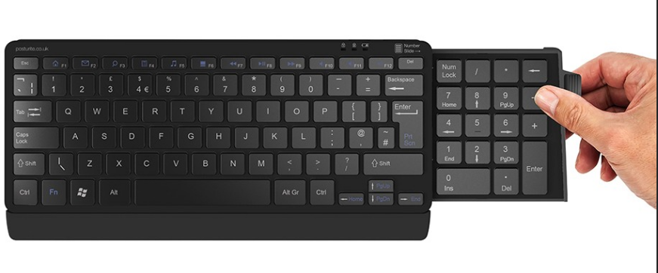
Mouse |  | Contour Design |  | RollerMouse RED (wired) |  | A slim ergonomic mouse alternative that reduces pain associated with mousing, the RollerMouse Free2 is based on our ergonomic expertise and inspired by users creating a modern ergonomic design with ultra-high precision and quality. RollerMouse Red helps to eliminate reaching for a traditional mouse: relieving neck, shoulder, elbow, and wrist pain. There is no gripping necessary, thus avoiding the threat of repetitive strain injuries such as Carpal Tunnel Syndrome and Tendonitis.  Mouse Dimensions (height x width x depth):  Width 43 cm, Height 2.3 cm, Depth 15.5 cm, and wrist rest depth 13 cm |  | 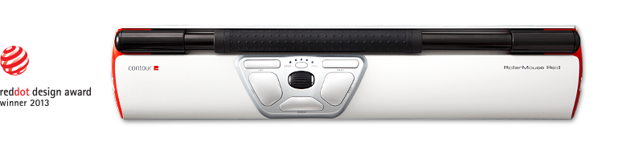
Mouse |  | Contour Design |  | UniMouse (wireless) |  | Posture variation is the cornerstone of ergonomics, which is why we designed Unimouse so that you can explore its 4 friction-based points of articulation to find your own unique comfort. Effortlessly switch postures on the fly and engage different muscles and tendons while avoiding fixed, static positions. The mouse may be inverted into vertical or semi-vertical mouse. |  | 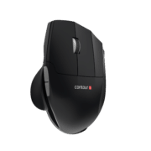
Mouse |  | Logitech |  | Logitech Trackman Marble (wired) |  | - Left-handed and right-handed trackball mouse  - A trackball design with a long, broad palm area and gentle curves keeps your hand comfortable and supported all day  Mouse Dimensions (height x width x depth):  3.41 in x 6.51 in x 1.67 in |  | 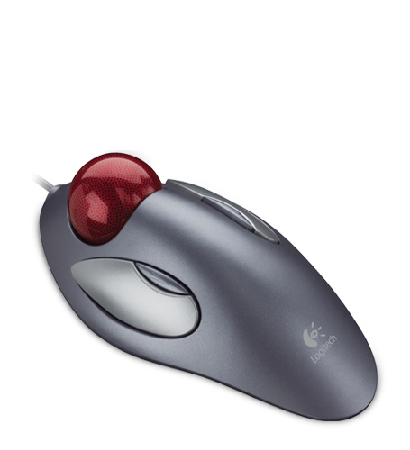
Mouse |  | Logitech |  | Logitech Mouse M500 (wired) |  | Hyper-fast scrolling  Precise laser tracking  Comfortable, contoured design  Two thumb buttons  Mouse Dimensions (height x width x depth):  2.72” x 4.96” x 1.65” |  | 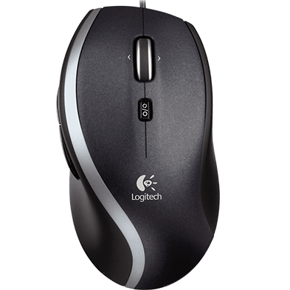
Mouse |  | Goldtouch |  | Semi-Vertical Mouse Wireless (right-handed) – Medium with Dongle (wired) |  | The Goldtouch Semi-Vertical Mouse was created with an optimal slope of 66 degrees for the user who wants a mouse that is midway between a traditional ergonomic mouse and vertical mouse. Unlike vertical mice, you'll have the power of gravity on your side when it comes to clicking, so you won't have to use as much movement between the thumb and fingers (which in turn can require more pinching of your muscles and nerves).  Sizing: Users with hands up to 7.5" can comfortably use this mouse. If the attachment flange accessory is added, users with hands up to 8" can comfortably use this mouse. |  | 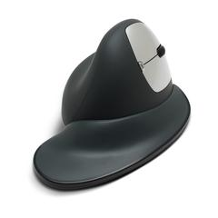
Mouse |  | Posturite |  | Penguin Ambidextrous Vertical Mouse (wireless) |  | - The vertical alignment encourages a more ergonomic operating position  - Ambidextrous Design- Central 'bow-tie' switch allows for easy transition between right and left handed use.  - Easy-glide symmetrical base - Allows the user to rest either hand comfortably alongside the vertical structure, encouraging the use of the bigger muscles in the fore and upper arm to maneuver the mouse. Fine cursor control is still achievable with small hand and/or finger movements  - Precision performance laser - Provides accurate tracking on typical work surfaces  - Adjustable 400, 600, 800 or 1200 dpi settings- Encourages fast and precise operating movements  - Precision scroll wheel - For fast, accurate document scrolling  - Soft key touch - Low activation force and full key travel distance provides keying comfort |  | 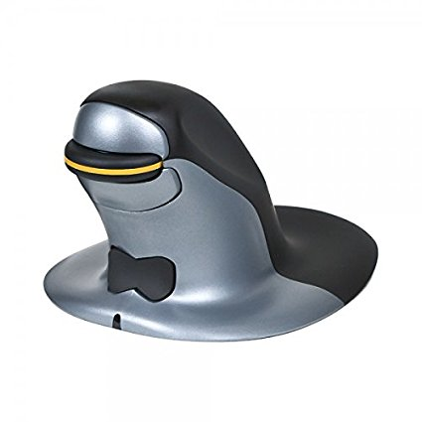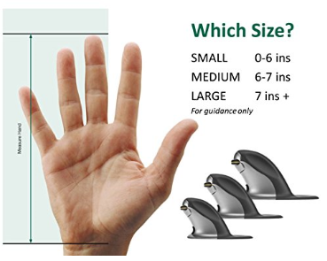
Task Light | Humanscale |  | Nova task Light, Jet Black  Size: Standard or XL  - Clamp Base  - Desktop Base |  |  | Designed to complement any work surface and enhance any workstyle, the new Nova task light offers endless adaptability in a striking, sculptural form. The custom lens and LED array create a uniform pool of glare-free light that can be adjusted exactly to each user's preference. Energy Star-certified to benefit people and the planet, Nova is a lighting solution for today and the future.  Measurement:  Standard Size: Lower arm: 13.8”  Upper arm: 13”  XL Size: Lower arm 15.9”  Upper arm: 15.1”  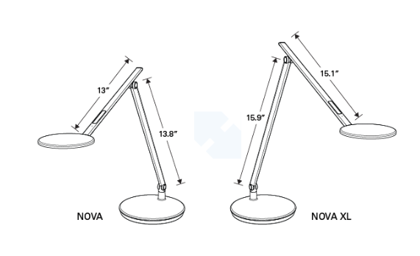 | 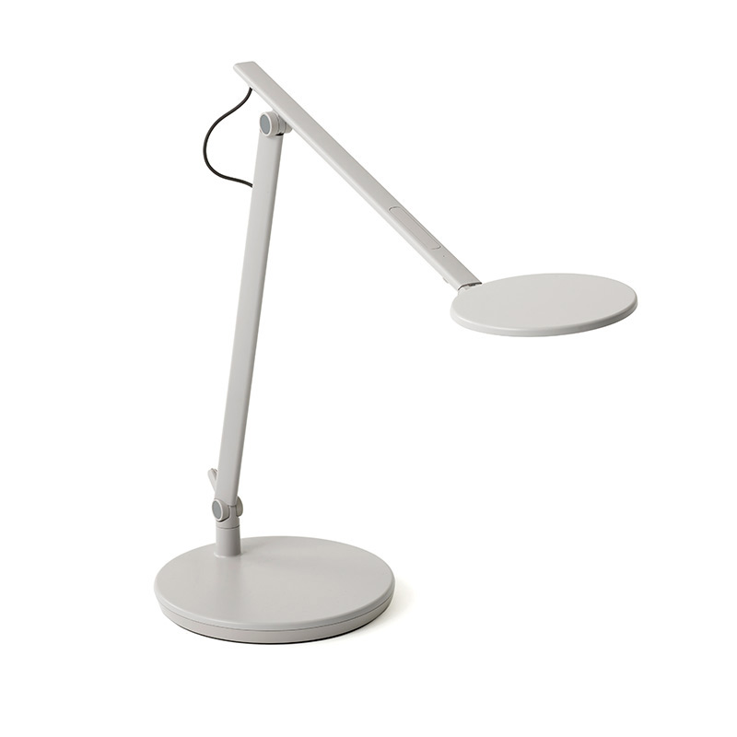  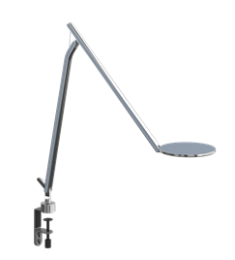
Headset | Plantronics |  | CS540/HL10 (with lifter)  Item#: 84691-11 |  | Wireless headset, customizable wearing options to match personal style. Convertible over-the-ear or over-the-head monaural options. Up to 7 hours of talk time. Includes HL10 handset lifter for remote call control. Voice-dedicated technology provides better audio and eliminates interference from Wi-Fi networks while advanced wideband audio provides high definition voice quality.  NOTE: Contact IT before purchase. |  | 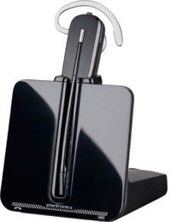
Monitor Arms | Grand Stands |  | Pro ERGOFlex2 LCD Monitor Arm Desk Grommet & Clamp Mount |  | - New, Sleek Low-Profile Design; VESA Mount Compliant  - 13" of Instant Height Range Plus Additional Pole Height Adjustment  - Standard 12" Pole, Optional 16" or 24" Pole for Additional Height Range  - Wire Management Channels to Keep Your Workspace Looking Clean & Organized  - Silver Finish with White Accents; Supports Monitors Up to 20 lbs. |  | 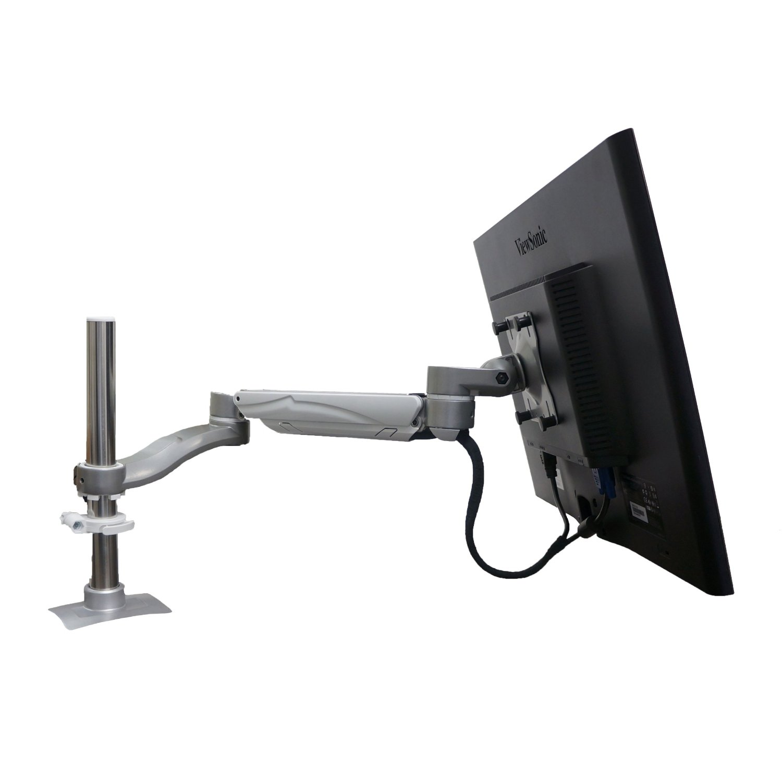
Monitor Arms | Humanscale |  | M/Flex |  | Introducing the world’s most scalable monitor support solution. The M/Flex monitor system enables swift and simple reconfigurations without disrupting existing equipment or adding new components. Providing unprecedented flexibility, M/Flex supports up to six monitors from a single post, in any configuration, or up to twelve monitors from two posts connected via crossbars. |  | 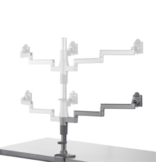
Monitor Riser | 3M |  | Adjustable Monitor Stand, MS80B |  | - Contemporary design with stacking columns raises monitor from 1" to 5 7/8" in increments of 1 5/8" to an ergonomically correct level  - Features 11" of storage space underneath to maximize desk space |  | 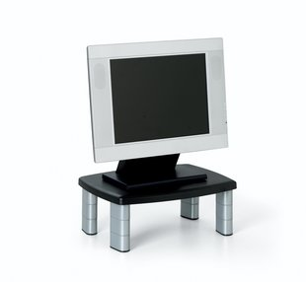
Laptop Holder | 3M |  | 3M™ (adjustable) Vertical riser |  | 3M™ Vertical riser in black color measuring 9.5" x 8.25" x 8" has non-skid base with holding ledge and provides 3" vertical height adjustment for convenient use. Riser is compatible with most docking stations.  - Black  - 9.5"H x 8.25"W x 8" L  - Tilt angle: 90 deg  - Positions your notebook screen at an ergonomically correct height and helps free up desk space  - Non-skid base  - Riser has 3 inches of vertical adjustability and is compatible with most docking stations  - Cable management feature keeps cords organized  - Compatible with docking stations  - Weight capacity: 5 - 20 lbs |  | 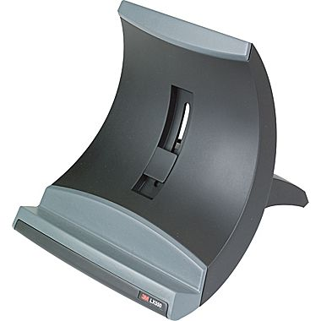
Laptop Holder | Ergotron |  | Ergotron laptop holder Neo-Flex® Notebook Lift Stand (black)  33-334-085 |  | - Includes stand, cable ties, hook and loop, adhesive non-slip pads  - Designed for use with a separate, external keyboard for proper ergonomics  - Height Adjustment: A combination of lift and tilt can move the height of a notebook’s screen through a 6" (15 cm) range  - Offers true ergonomic height/tilt adjustment—six-inch (15 cm) motion range places top of screen at proper eye level for maximum viewing comfort  - Up to 360° of side-to-side swivel  - Weight adjustable design—3.5–14 lbs (1.6–6.3 kg)—is compatible with most laptops, with or without port replicator  - Product Weight: 3.6 lbs (1.6 kg)  - Warranty: Three (3) years |  | 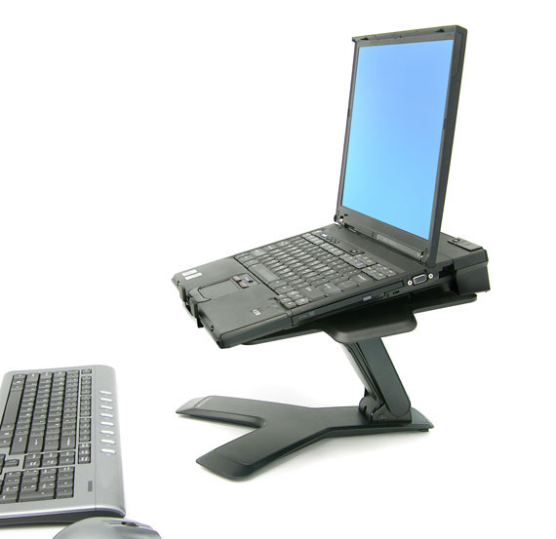
Mouse Wrist Rest | Kensington |  | Wrist Pillow® Mouse Wrist Rest – Black  73535578226 |  | - Pillow foam for soft, durable support  - Non-skid base keeps wrist rest firmly in place  - Rest provides comfortable support that's large enough for any mouse or trackball  - Large surface eliminates pressure points to improve comfort  - Wrist rest easily conforms to hand without restricting motion  - Large mousing surface for all-day ease and comfort |  | 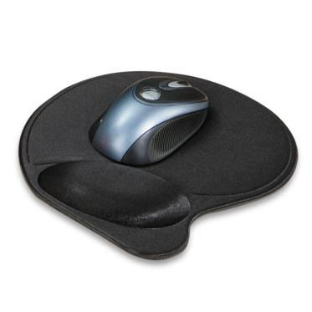
Mouse Wrist Rest | IMAK Ergo |  | Wrist Cushion for Mouse |  | IMAK Ergo Wrist Cushion for Mouse is filled with massaging ergoBeads, making for the most comfortable ergonomic wrist support available. The unique design is shaped for easy maneuvering of the mouse, while comfortably supporting your wrist and forearm for eliminate stress. |  | 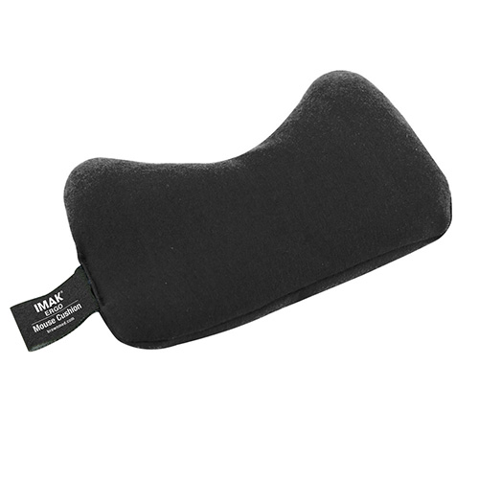
Keyboard Wrist Rest | Kensington |  | Wrist Pillow® Keyboard Wrist Rest – Black  735353228015 |  | - Pillow foam for soft, durable support  - Rest provides comfortable support that's wide enough for any keyboard and numeric pad  - Wide support works with all keyboard widths and styles  - Large surface eliminates pressure points to improve comfort  - Wrist rest easily conforms to wrist without restricting motion  - 19.25”L X 3.5” W X 1.0” H |  | 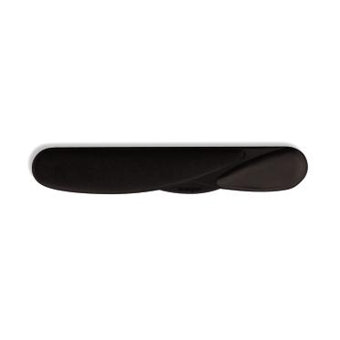
Electric Stapler | Stanley Bostich |  | Premium Impulse Drive Electric Full Strip Stapler  20 Sheet Capacity  Item #: 790113  45 Sheet Capacity  Item #: B8E-VALUE |  | - Electric full strip stapler  - 20 or 45 sheet capacity available. |  | 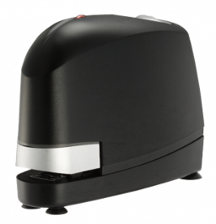
Electric Hole Punch | Swingline |  | Optima 20 Electric Punch  Item #: A7074520 |  | - Compact electric hole punch is lightweight and easily portable, powered by an AC adapter or 6AA batteries.  - Efficient electronics combined with alignment indicators provide professional looking results. |  | 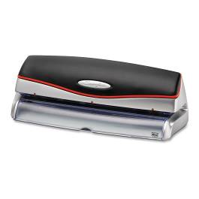
Corner Sleeve | Workrite |  | 179ACD-B  Adjustable Corner Diagonal |  | - Converts 90º & curved corners (up to 9″) to usable work areas  - Allows use of adjustable arm and keyboard platform when the natural corner of the worksurface does not permit it  - Adjusts to fit 1″ to 2.25″ thick worksurfaces  - Clamping design eliminates spacers, saving installation time  - Dimensions: 12″W × 1.75″H |  | 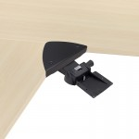
Corner Sleeve | Humanscale |  | - DE-200 (Corner sleeve fits desks 1” to 1.5”, 16” diameter)  - DE 250 (Corner sleeve fits desks 1.5” to 2.5”, 16” diameter) |  | - 16” Corner Sleeve |  | 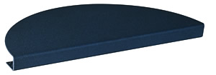
Floor Mat | Ultra SmartMat |  | Ultra SmartMat |  | The Ultra Smart Mat in our Classic Black color. The same thickness, cushion and function as the Premium Smart Mat with an antimicrobial rubber top treated for the life of the product.  Overall Mat Thickness: 3/4” (includes cushion, backing and surface materials)  Size: 32"x21"  Surface Type: Nitrile Rubber  Cushion Type: Nitrile Closed Cell Cushion  Thickness: .625” |  | 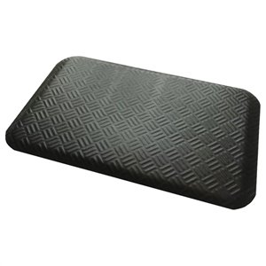
Voice Activation Software | Zephyr-TEC |  | - Software  - Training |  | - Dragon® 13 Premium takes voice command to the next level with enhanced features for greater accuracy and speed when creating documents, emailing, searching the web and more - at work, school, on the go, or in the office. Get the world's best-selling and most accurate speech recognition software for the PC, used by millions of people. |  | 
Wheeled Case for Mobile Work Assignment | CODI |  | C9020 |  | - Business organization system located in the front compartment  - Telescoping twin tube handle for stability and easy towing  - 1050D ballistic nylon and leather makes this case extremely lightweight and durable  - Computer compartment includes a padded removable notebook sleeve that accommodates most 15.4 inch wide screens  - Pyramid shaped pockets provide easy access to cell phones, boarding passes and PDAs  - Dimension: 14.5” L X 16” W X 8.8” H |  | 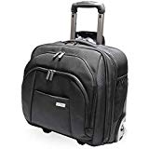

SIT AND STAND EQUIPMENT
Electric Adjustable Table | Ergotron |  | Workfit Electric Sit-Stand Desk  - 98-353-921  46 inches wide  - 98-354-921  58 inches wide  NOTE: Must purchase tabletop with legs. |  | Height ranges must be at least 23” to 49”. |  | N/A
Electric Adjustable Table | Grand Stands |  | Stage: L3 |  | Height ranges must be at least 23” to 48”. |  | N/A
Electric Adjustable Table | Workrite |  | 1) Sierra HX  2) Fundamental EX |  | Height ranges must be at least 22.5” to 48.7”. |  | N/A
Sit and Stand Platform | Humanscale |  | 5GAD550F22  NOTE: Above desk keyboard tray |  | Recommend for petite users because it drops lower than other trays. If used while standing, only use for employees with 5’2” or less of height. 550 tray is designed to keep both mouse and keyboard on same surface allowing closer reach to mouse.  The 5G Above Desk mechanism has a 13.5” height adjustment range – 7.5” above track to 6” below track. Comes with synthetic foam wrist rest and standard 27” track.  The height range adjustment is 5” from where it is mounted under the desk. The height adjustment above the desk surface depends on thickness of desk surface. If you have a 3” thick work surface, it will only raise about 2” above the desk. If you have a 1” thick work surface, it will raise 4” above the desk. |  | 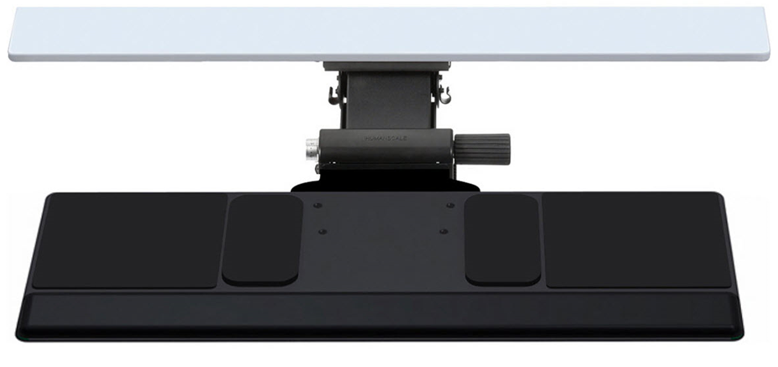
Sit and Stand Platform |  | Ergotron |  | 24-391-026 (single)  24-392-026 (dual)  NOTE: Desk clamp attaches to edge up to 2.5" thick; grommet mount attaches through hole 0.5" to 2.5" wide and up to 2.5" thick |  | This premium stand-up desk solution adds extra ergonomic benefits, allowing the keyboard tray to be positioned below desktop level for optimum computing comfort.  A WorkFit height-adjustable workstation moves your keyboard and monitor in one simple motion—change from a sitting to a standing position whenever you want. Fold your keyboard up and swing the arm out of the way when you need your desk surface.  NOTE: This product will not fit a petite person if using the keyboard tray while sitting. |  | 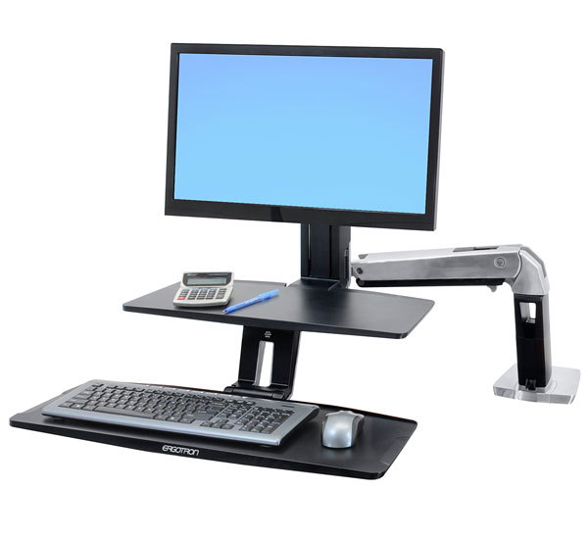
Sit and Stand Platform |  | Ergotron |  | 33-351-200 (single)  33-349-200 (dual)  NOTE: Desk Clamp attaches to surface edge .47" to 2.4" (1.2 to 6 cm) thick |  | Convert any surface into an adjustable-height standing desk with the attachment of the WorkFit-S. Make computing comfortable for prolonged periods—stand up whenever you want. |  | 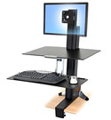
Sit and Stand Platform  NOTE: Sit and Stand Keyboard Tray for Petite person |  | Workrite |  | Ultra-Thin Platform  and Extended Range Arms 22”– Pinnacle AD  UB185-25 (platform) /3176-22TG (track) |  | Compact Platform System  - Sized for compact keyboards less than 6″ deep  - UltraThin™ .25″ solid phenolic construction  - Removable memory foam palm support  - Right/Left configurable  - Available in black  Extended Range Arms – Pinnacle AD  - Adjusts from 7.25″ above to 53/4 below the work surface  - Tilt range from -15° to +10°  - 360 degree swivel for easy positioning and storage  - Independent height and angle controls  - Low profile ball bearing track is 5.75″ wide and is available in 17″, 22″ or 28″ length  Available in black only  - 17″ track has 6″ of platform storage  - 22″ track has 11″ of platform storage  - 28″ track has 17″ of platform storage |  | 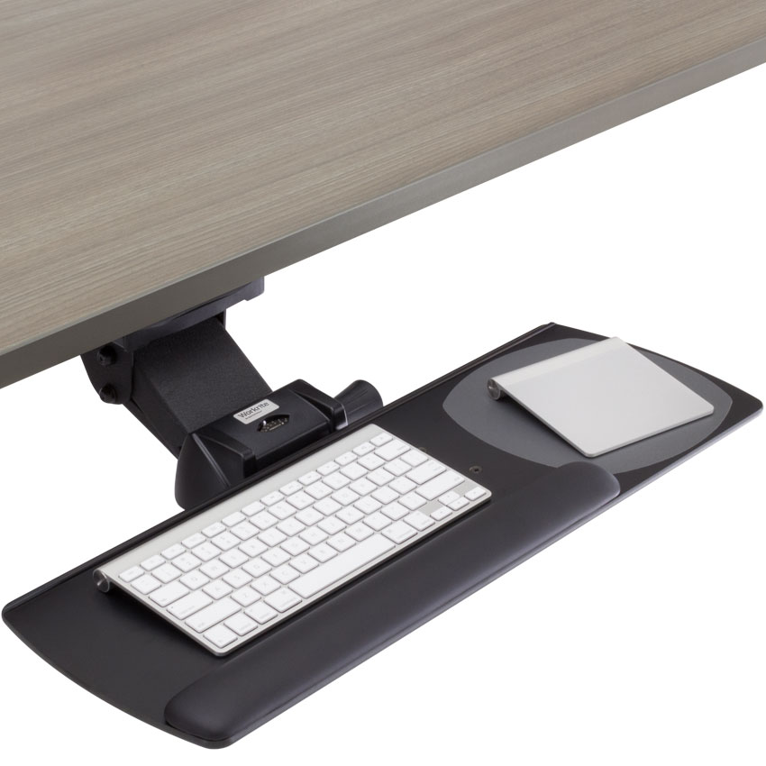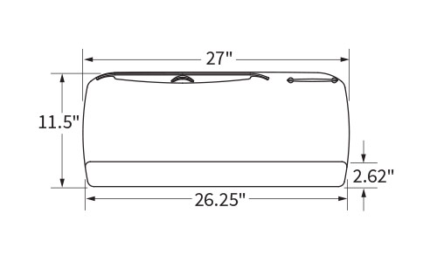  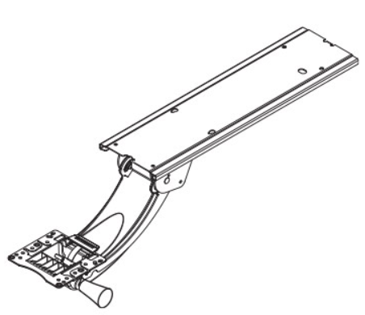
Sit and Stand Platform |  | Workrite |  | - Single Monitor: Solace 2 Sit To Stand  Standard / None – (single monitor)  - Dual Monitor:  Solace 2 Sit To Stand  Standard / Dual Monitor Adaptor |  | Solace 2 promotes health and wellness by providing the core ergonomic benefits associated with height adjustable desks, monitor arms, and keyboard platforms. The all-in-one ergonomic workstation offers a quick & economical method to enhance user comfort as well as overall productivity. With it’s broad range of lift, rotation and tilt, Solace 2 has the flexibility to accommodate a wide variety of users and applications.  Arm Features:  -14–32 lb. load capacity  -22" lift range  -360° rotation at base, 180° rotation at monitor mount  -Monitor tower and keyboard platform rotate independently  -Available in silver  -Warranty: 5 years Monitor  Mount Features:  -Supports one 6.5–24.5 lb. monitor or two 1.25–10.25 lb. monitors with optional Dual Monitor Adaptor (max. 22" wide)  -9.5" independent monitor height adjustment Standard  Keyboard Platform Features:  -Features our Standard UB182-25 Keyboard Platform  -In-Line mousing for right and left handed users  -3.75" independent keyboard platform adjustment |  | 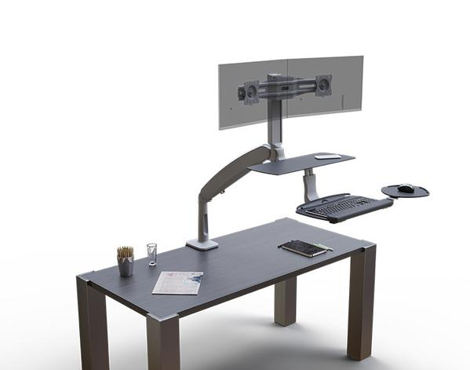
Sit and Stand Desk Converted |  | Ergotron |  | WorkFit-TX  (Hand-held Adjustment) |  | - Delivers leading ergonomics sitting or stand with 17” of vertical height adjustment, plus 3” of keyboard adjustment  - Thoughtful, ultra-low design offers a sleek look and ergonomic fit for a wide range of users  - Large worksurface keep office essential nearby  - Drop-down tray places your keyboard at the most comfortable ergonomic position  Measurement:  Worksurface 32” X 27”  Keyboard Tray: 28” X 8”  Warranty: 5 years |  | 

