1. POLICY

It is the policy of DEPARTMENT NAME to provide its employees with a safe and healthful work environment. This program was developed in accordance with the requirements contained in Title 8, California Code of Regulations, Section 3220 (Appendix A).

2. PURPOSE

The purpose of this program is to protect employees from serious injury or loss of life, and minimize property loss in the event of an emergency or disaster.

3. SCOPE

This document applies to all DEPARTMENT NAME personnel, facilities, and operations. All personnel shall comply with the provisions outlined in this document.

4. EMERGENCY ESCAPE PROCEDURES AND ROUTE ASSIGNMENTS

Emergency Escape Procedures

Emergency escape procedures and route assignments are posted in each work location (SPECIFY LOCATION). The locations of fire extinguishers, first aid kits and fire alarm manual pull stations are identified on the map. Appendix B also contains a copy of the escape route assignments.

In the event of an emergency or if directed by security/emergency personnel, DEPARTMENT NAME personnel should remain calm, walk to the nearest exit and leave the building. Designated searchers will search rooms (closing doors to each room after it is searched) prior to evacuating. Stairwell monitors will direct personnel to the nearest emergency exit stairwell and ensure personnel do not attempt to reenter the area. After exiting the building, DEPARTMENT NAME personnel should proceed to the designated refuge location and follow instructions from the Floor Warden. Floor Warden, Searchers and Stairwell Monitors are listed in Appendix C.

Employees Who Remain to Operate Critical Operations Prior to Evacuation
(If applicable)

Designated personnel have responsibilities to operate, shutdown or isolate critical operations prior to evacuation. These assignments are necessary to ensure proper emergency and hazard control. If the evacuation alarm sounds or if an evacuation is ordered, these individuals should remain in the facility and perform the necessary procedures to ensure critical operations are shut down, isolated, etc. prior to evacuation. At no time should these individuals remain in the building if there is risk to their safety and health.

Appendix D contains the inventory of critical operations and assigned responsible personnel.

Accounting for Employees after Evacuation

Supervisors (or their designees) are responsible for accounting for personnel which are assigned to them by utilizing an employee list/attendance sheet and checking off the names of all employees at the designated refuge location (the list should be obtained by the Supervisor prior to evacuating the facility). Supervisors will provide the names of those employees not accounted to the Floor Warden. Each Floor Warden will provide their headcount and list of unaccounted employees (if any) to the Building Emergency Coordinator (BEC).

The BEC will be located at one of the following locations:

Primary location: _________________________
Secondary location: _________________________

Rescue and Medical Duties

Rescue and medical duties have been assigned to designated individuals. These personnel have received specific training and instructions for properly carrying out these assignments. A list of employees who have been assigned rescue and medical duties are listed in Appendix C. A description of their responsibilities can also be found in the appendix.

Preferred Means of Reporting Fires and Other Emergencies

The preferred means of reporting fires and other emergencies is by phone. Emergency phone numbers are posted at each workplace in a conspicuous location (Appendix E).

Persons to Contact for Further Information

A copy of the written Emergency Action Plan can be viewed at INSERT LOCATION. Please contact INSERT NAME, TITLE at INSERT TELEPHONE NUMBER for more information regarding the Plan.

5. ALARM SYSTEM

Notification of an emergency or evacuation is communicated to employees through the fire alarm or building intercom system (if applicable). Employees using the intercom should speak slowly and clearly, describe the area in which the emergency is located and direct employees to evacuate the building and meet at the designated refuge location.

6. EMERGENCY SITUATIONS

THE FOLLOWING ARE SUGGESTED SAMPLE SITUATIONS. ADD AND DELETE SITUATIONS AS APPROPRIATE

Fire

If you discover a fire, evacuate everyone in immediate danger and confine the fire by closing all doors and windows to the fire area (if safe to do so). Activate a manual fire alarm pull station and proceed to the designated refuge location. Call emergency personnel (911 or 9-911) from a safe location and provide the following information: building address, nearest cross street, floor/suite number, nature of the emergency and your call back number - do not hang up until told to do so.

Use a fire extinguisher if safe and only if you are trained to do so. Never attempt to put out a fire alone.

Earthquake

If an earthquake occurs, remain calm. If you are indoors, take cover under a desk, table or bench or sit down with your back against an inside wall. If possible, move away from windows. If you are inside an elevator, exit at the first opportunity. If the elevator becomes disabled, activate the alarm and use the telephone to summon help. If outdoors during an earthquake, get to an open space (if safe to do so) and stay away from buildings and power lines.

If indoors, evacuate the building after the earthquake and proceed to the designated refuge location. Assess yourself and others for injury and for damage in your immediate area. Evacuate the refuge location if conditions exist that impact your safety and health. Prepare for aftershocks.

Bomb Threat

A bomb threat may be received by phone or mail. Although most bomb threats are just threats, every threat should be taken seriously and investigated.

Upon receipt of a written threat or suspicious package, prevent anyone else from handling it and call 911 or (9-911) and follow the operator’s instructions. Save all materials, envelopes and containers and avoid unnecessary handling to preserve fingerprints, handwriting, printing, postmarks, etc. Suspicious letters and packages may have the following characteristics: excessive postage, lack of a return address, excessive weight, incorrect titles, restrictive markings (i.e. confidential, personal, etc.) and oily stains or discolorations.

The majority of bomb threats are communicated by telephone. If a telephone bomb threat is received, remain calm and write down the exact wording of the threat. Note background sounds, caller’s voice and accents. Do not put the caller on hold and don’t hang up until the caller does. Immediately call 911 (or 9-911) and follow the operator’s instructions. Complete a Telephone Bomb Threat Report (Appendix F).

7. TRAINING

Training on the Emergency Action Plan will be conducted initially when the Emergency Action Plan is developed, whenever an employee’s responsibilities or designated actions change, whenever the Plan is revised and initially when employees are first hired to the Department. Training participation and attendance should be documented on a Training Record (Appendix G) or equivalent form.

Training will consist of overview of the Emergency Action Plan, identification of emergency exit routes, designated refuge location, and expected responses during specified emergencies, emergency telephone listings, alarm systems and responsibilities.

A sufficient number of personnel will also be designated specific roles and responsibilities during evacuations to ensure in the safe and orderly evacuation in the event of an emergency. Appendix B contains a list these individuals and their designated roles.
8. ANNUAL PROGRAM REVIEW

The BEC will review the Emergency Action Plan annually, whenever the Plan is changed, and whenever an employee’s responsibilities or designated actions under the Plan change. The review and any changes to the Plan should be documented in (Appendix H).

APPENDIX A

§3220 Emergency Action Plan

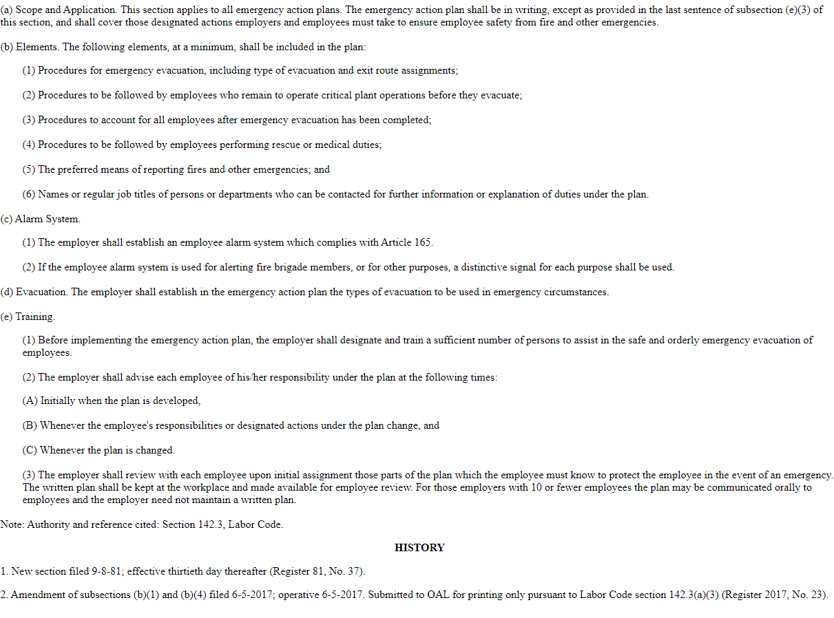

APPENDIX B

ESCAPE ROUTE ASIGNMENTS (SAMPLE)

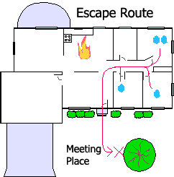

APPENDIX C

Assigned Responsibilities and Duties

Assigned Position/Responsibility Name_________________________

Building Emergency Coordinator: ______________________________
Alternate: ______________________________

Description of Responsibilities: ____________________________________________
_____________________________________________________________________
_____________________________________________________________________

Floor Warden: ______________________________
Alternate: ______________________________
Description of Responsibilities: ____________________________________________

_____________________________________________________________________
_____________________________________________________________________

Searcher: ______________________________
______________________________
______________________________

Description of Responsibilities: ____________________________________________
_____________________________________________________________________
_____________________________________________________________________

Stairwell Monitor: ______________________________
Alternate: ______________________________

Description of Responsibilities: ____________________________________________
_____________________________________________________________________
_____________________________________________________________________

Mobility Assistant: ______________________________
Alternate: ______________________________
Description of Responsibilities: ____________________________________________
_____________________________________________________________________
_____________________________________________________________________
First Aid Responder: ______________________________
Alternate: ______________________________

Description of Responsibilities: ____________________________________________
_____________________________________________________________________
_____________________________________________________________________

Fire Extinguisher Responder: ______________________________
Alternate: ______________________________

Description of Responsibilities: ____________________________________________
_____________________________________________________________________
_____________________________________________________________________

Communication/Runner: ______________________________
Alternate: ______________________________

Description of Responsibilities: ____________________________________________
_____________________________________________________________________
_____________________________________________________________________

APPENDIX D

Critical Operations Inventory

Operation/Procedure Assigned Personnel/Title

1. _____________________________ ______________________________
______________________________
______________________________

2. _____________________________ ______________________________
______________________________
______________________________

3. _____________________________ ______________________________
______________________________
______________________________

4. _____________________________ ______________________________
______________________________
______________________________

5. _____________________________ ______________________________
______________________________
______________________________

APPENDIX E
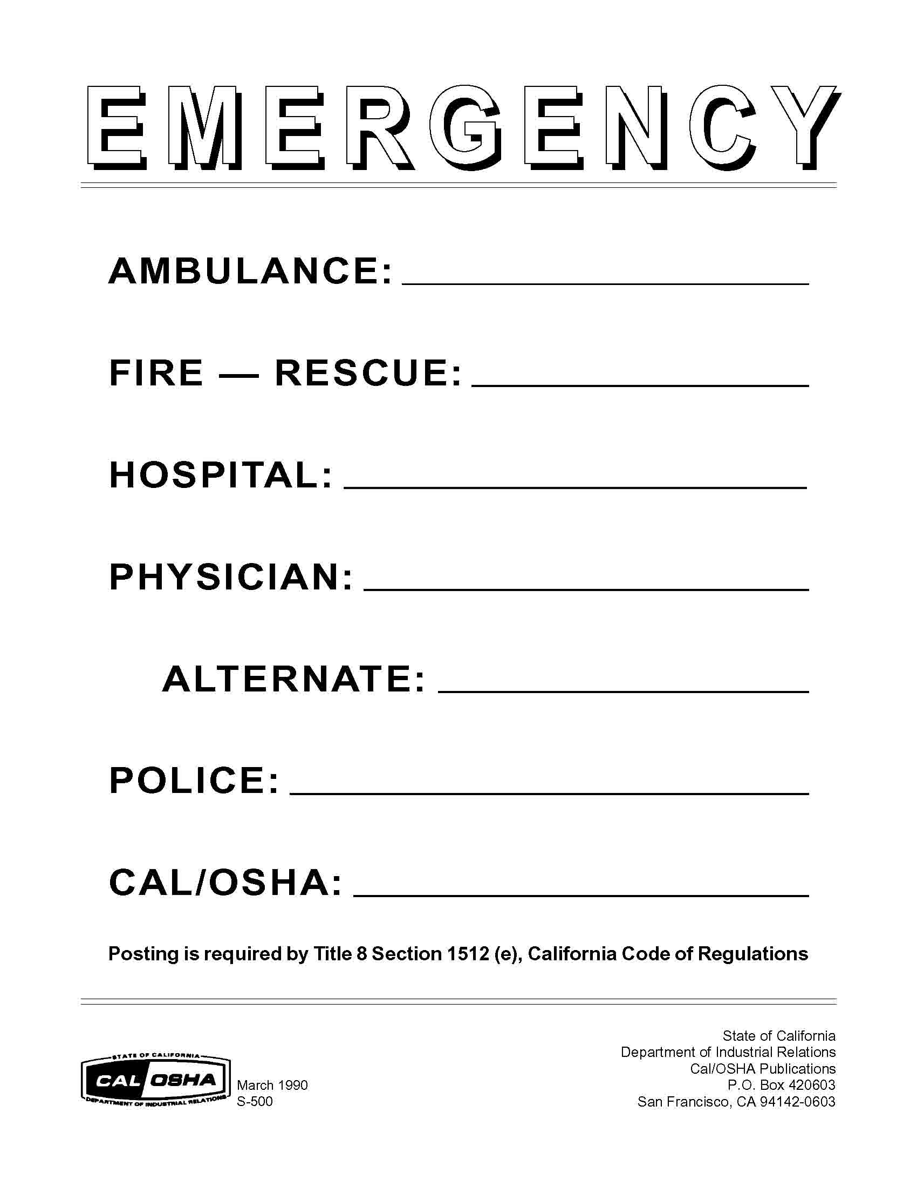

APPENDIX F

Telephone Bomb Threat Report Form

QUESTIONS TO ASK CALLER’S VOICE

1. When is bomb going to explode? Calm Nasal
2. Where is it right now? Angry Stutter
3. What does it look like? Excited Lisp
4. What kind of bomb is it? Slow Raspy
5. What will cause it to explode? Rapid Deep
6. Did you place the bomb? Soft Ragged
7. Why? Loud Clearing throat
8. What is your address? Laughter Deep breathing
9. What is your name? Crying Cracking voice
Normal Disguised
EXACT WORDING OF THREAT Distinct Accent
______________________________ Slurred Familiar
______________________________
______________________________ If voice is familiar, who did it sound ______________________________ like? _______________________
______________________________ ____________________________
______________________________
______________________________ BACKGROUND SOUNDS
______________________________
______________________________ Street noise Factory
Crockery Machinery
Sex of caller: _______ Race: ______ PA system Animal noises
Age: _____ Length of call: ________ Music Static
House noises Local
Number at which call was received: Motor Long distance
______________________________ Phone booth Office equipment
Time: _______ Date: ___________ Other: ______________________

Person taking call: _______________ THREAT LANGUAGE
______________________________
Position: ______________________ Well spoken Incoherent
Phone number: _________________ Irrational Foul
Date: _________________________ Taped

REMARKS: ___________________________________________________________
_____________________________________________________________________
APPENDIX G

Training Record

PRINT NAME | SIGNATURE | EMPLOYEE # | DATE

_______________________________ ___________ ________________
(PRINT INSTRUCTOR’S NAME) (EMPLOYEE NUMBER) (DATE)
_______________________________
(INSTRUCTOR’S SIGNATURE)
APPENDIX H

Program Review Form

Date(s) of evaluation: ________________________

Evaluation performed by: ________________________

General Plan reviewed:
Yes No

Comments: ___________________________________________________________

Have employees been trained in their assigned/designated responsibilities?
Yes No

Comments: ___________________________________________________________

Has the annual evacuation drill been conducted?
Yes No

Comments: ___________________________________________________________

Are evacuation routes and emergency phone listings posted?
Yes No

Comments: ___________________________________________________________

Are fire extinguishers and first aid kits inspected regularly and maintained/replenished as necessary?
Yes No

Comments: ___________________________________________________________

