1. POLICY

It is the policy of DEPARTMENT NAME to provide its employees with a safe and healthful work environment. This program was developed in accordance with the requirements contained in Title 8, California Code of Regulations, Section 3221 (Appendix A).

2. PURPOSE

The purpose of this program is to protect employees from serious injury or loss of life, and minimize property loss in the event of a fire.

3. SCOPE

This document applies to all DEPARTMENT NAME personnel, facilities, and operations. All personnel shall comply with the provisions outlined in this document.

4. MAJOR WORKPLACE FIRE HAZARDS

Potential Fire Hazards

The following list identifies the potential fire hazards at the worksite:

1. e.g. Flammable paints and solvents stored in the janitor’s closet.

2.

3.

Proper Handling and Storage Procedures for Potential Fire Hazards

The proper handling and storage procedures for the above mentioned fire hazards include:

1. e.g. Flammable paints and thinners will be stored in flammable cabinets.

2.

3.

Potential Ignition Sources

The following list identifies the potential ignition sources at the worksite:

1. e.g. Welding

2.

3.

Control Procedures for Potential Ignition Sources

Control procedures for the above mentioned ignition sources include:

1. e.g. Hot work permits are required before any welding activity commences.

2.

3.

Fire Protection Equipment or Systems

The type of fire protection equipment and/or systems located at the worksite include:

1. e.g. Fire Extinguishers

2.

3.

The evacuation map in Appendix B identifies the locations of fire extinguishers and fire alarm pull stations.

5. RESPONSIBLE PERSONS

The following individuals are responsible for the regular and proper maintenance of equipment and systems installed to prevent or control the ignition or fires:

Name Title

1. Jane Doe______________________ Supervisor___________________

2. ______________________________ ___________________________

3. ______________________________ ___________________________

The following individuals are responsible for control of the accumulation of flammable and combustible waste materials:

Name Title

1. John Doe______________________ Custodian_____________________

2. ______________________________ ___________________________

3. ______________________________ ___________________________

6. HOUSEKEEPING

The following procedures have been implemented to control the accumulation of flammable and combustible waste materials and residues:

- Trash, scrap, and waste will be removed during each shift.

2.

3.

7. TRAINING

Upon initial job assignment, employees shall be apprised of the fire hazards to which they are exposed, the location of fire-related protection equipment/systems and the procedure to report a fire. Training participation and attendance should be documented on a Training Record (Appendix F) or equivalent form.

If a fire is discovered, employees are instructed to:

- Evacuate everyone from the immediate area and close all doors and windows to the area (if safe to do so).

- Activate the nearest fire alarm pull station to evacuate the building.

- Notify emergency personnel (911 or 9-911) from a safe location. Emergency phone numbers are posted at each workplace in a conspicuous location (Appendix E).

- Use a fire extinguisher if safe and only if trained to do so. When attempting to fight a fire, never fight a fire alone and keep yourself between the fire and exit.

A copy of the written Fire Prevention Plan is maintained at INSERT LOCATION. Please contact INSERT NAME, TITLE at INSERT TELEPHONE NUMBER for more information regarding the Plan.

8. ANNUAL PROGRAM REVIEW

The Fire Prevention Plan should be reviewed whenever the Plan is changed or whenever an employee’s responsibilities or designated actions under the Plan change. The review and any changes to the Plan should be documented on the Program Review Form (Appendix G).

APPENDIX A

§3221 Fire Prevention Plan

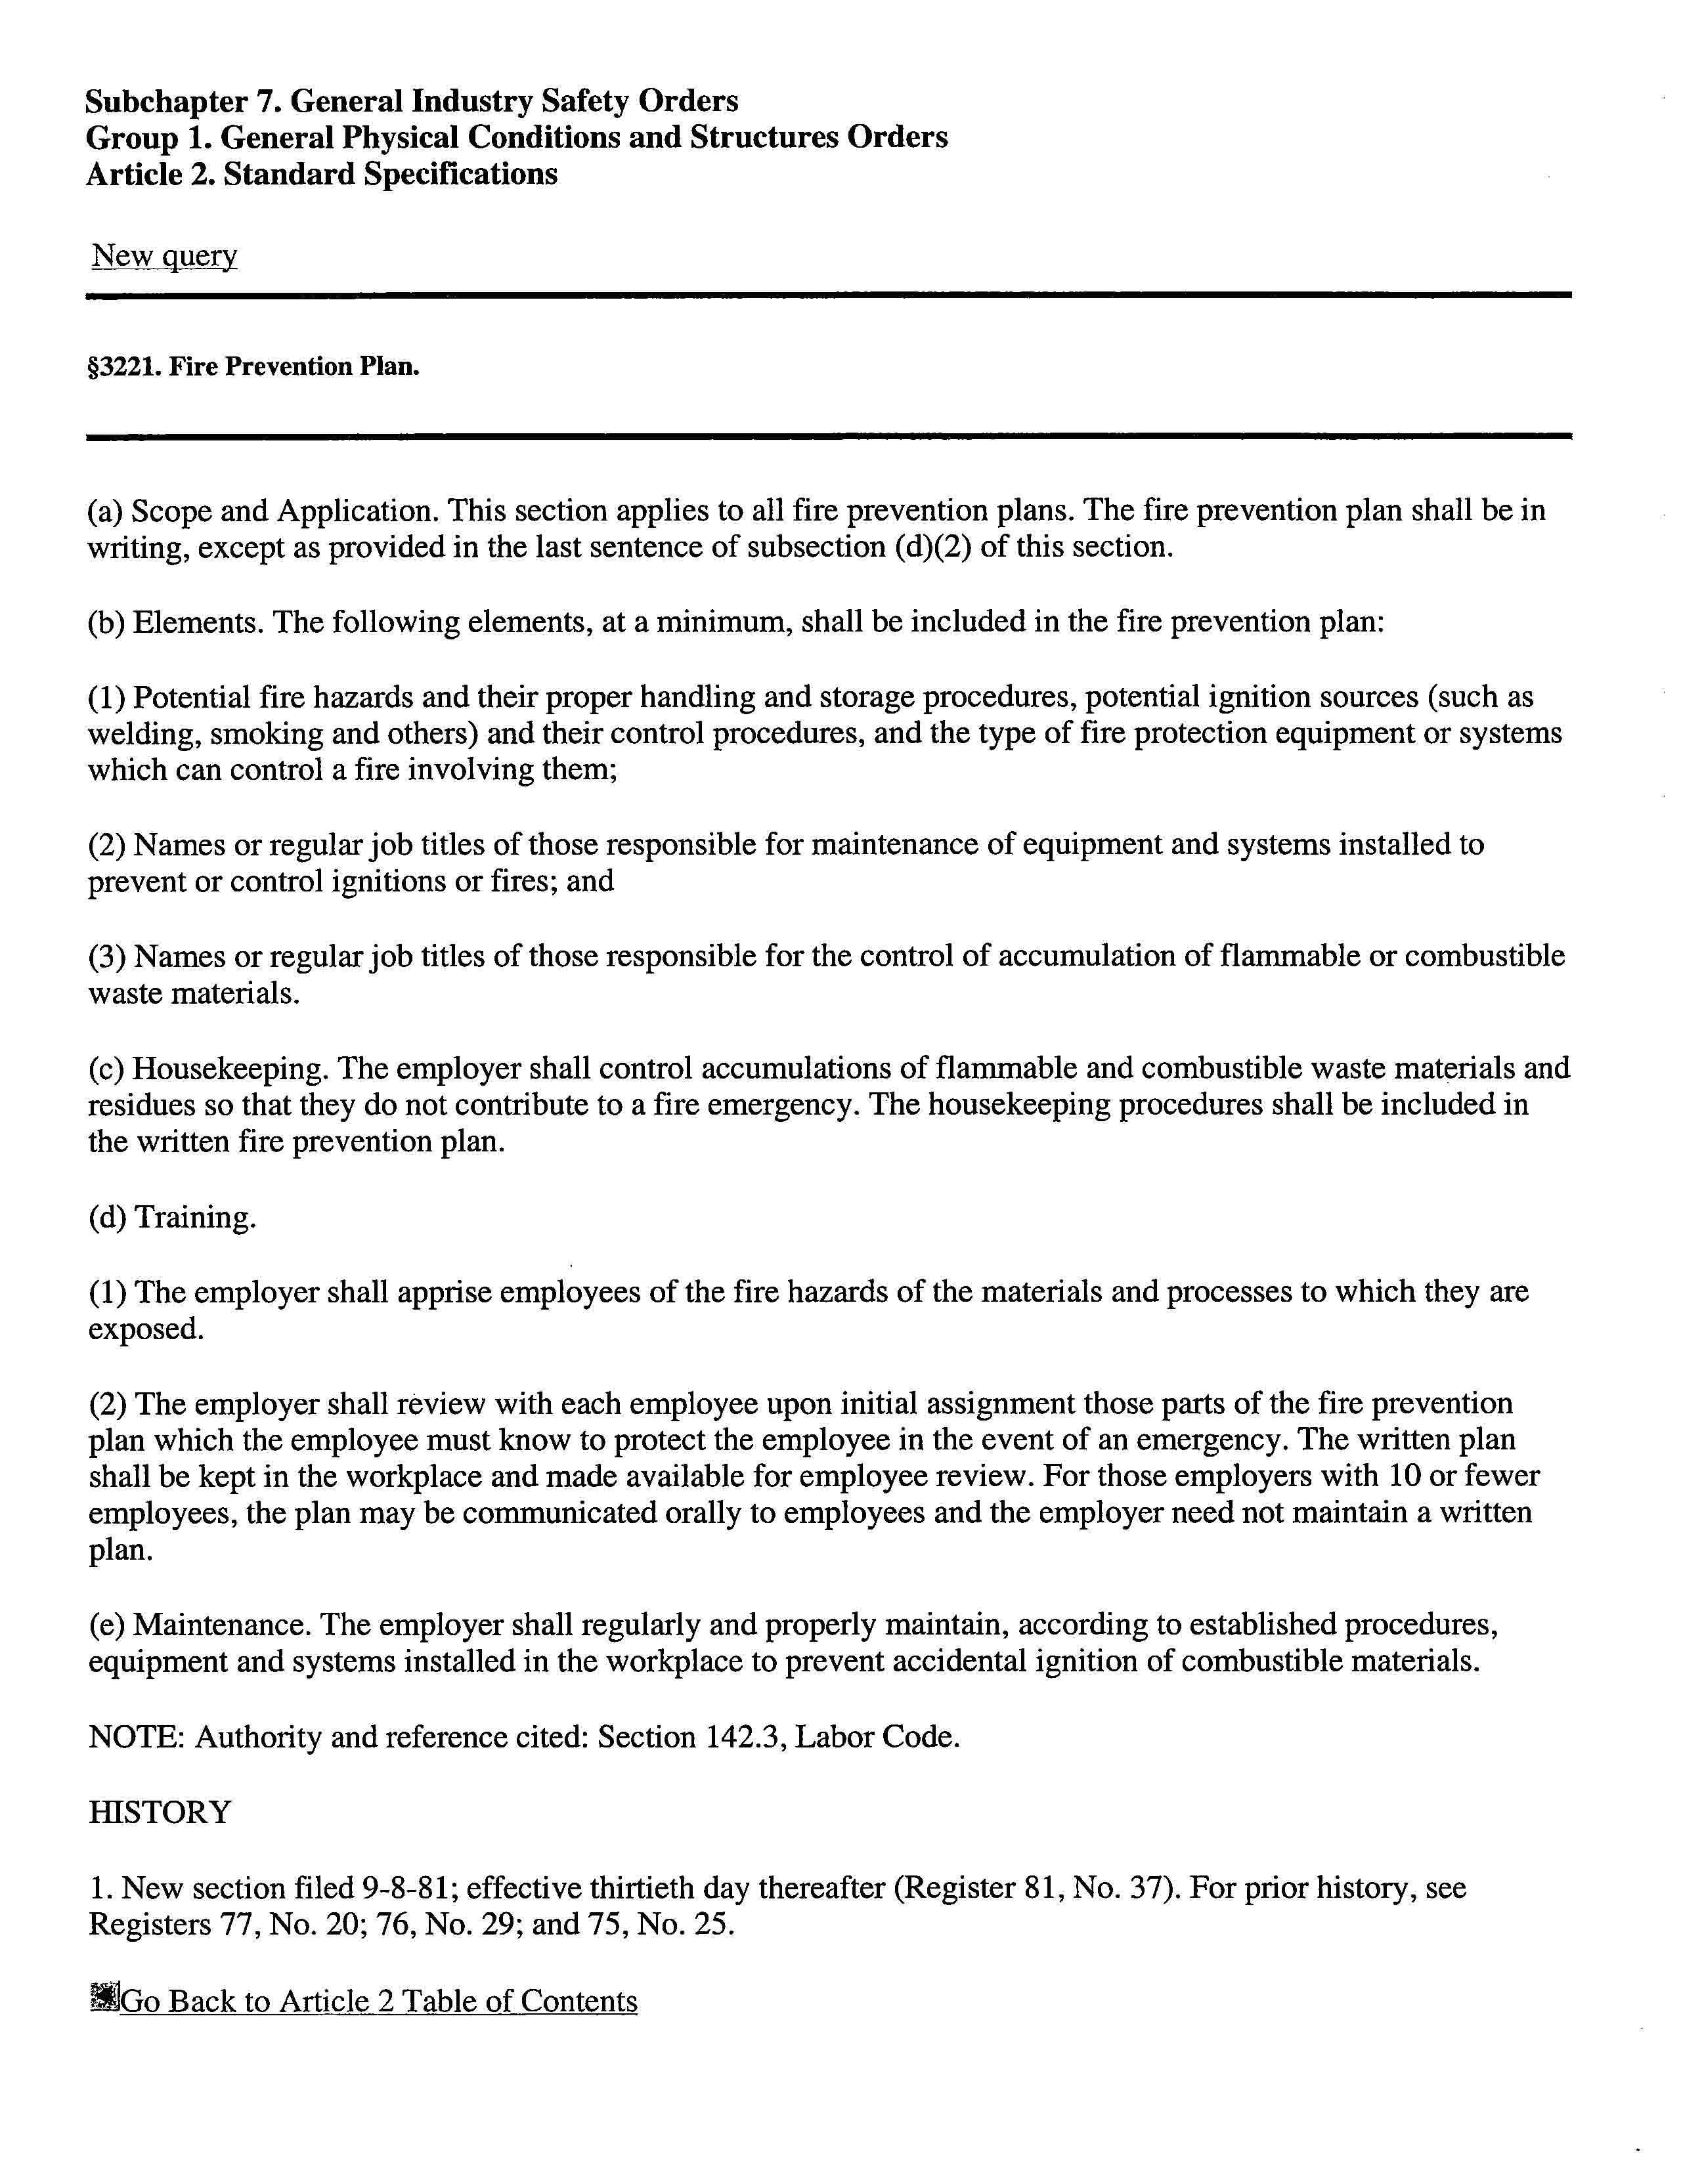

APPENDIX B

ESCAPE ROUTE ASIGNMENTS (SAMPLE)
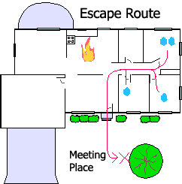

APPENDIX C

Assigned Responsibilities and Duties

Assigned Position/Responsibility Name_________________________

Building Emergency Coordinator: ______________________________
Alternate: ______________________________

Description of Responsibilities: ____________________________________________
_____________________________________________________________________
_____________________________________________________________________

Floor Warden: ______________________________
Alternate: ______________________________

Description of Responsibilities: ____________________________________________
_____________________________________________________________________
_____________________________________________________________________

Searcher: ______________________________
______________________________
______________________________

Description of Responsibilities: ____________________________________________
_____________________________________________________________________
_____________________________________________________________________

Stairwell Monitor: ______________________________
Alternate: ______________________________

Description of Responsibilities: ____________________________________________
_____________________________________________________________________
_____________________________________________________________________

Mobility Assistant: ______________________________
Alternate: ______________________________
Description of Responsibilities: ____________________________________________
_____________________________________________________________________
_____________________________________________________________________
First Aid Responder: ______________________________
Alternate: ______________________________

Description of Responsibilities: ____________________________________________
_____________________________________________________________________
_____________________________________________________________________

Fire Extinguisher Responder: ______________________________
Alternate: ______________________________

Description of Responsibilities: ____________________________________________
_____________________________________________________________________
_____________________________________________________________________

Communication/Runner: ______________________________
Alternate: ______________________________

Description of Responsibilities: ____________________________________________
_____________________________________________________________________
_____________________________________________________________________

APPENDIX D

Critical Operations Inventory

Operation/Procedure Assigned Personnel/Title

1. _____________________________ ______________________________
______________________________
______________________________

2. _____________________________ ______________________________
______________________________
______________________________

3. _____________________________ ______________________________
______________________________
______________________________

4. _____________________________ ______________________________
______________________________
______________________________

5. _____________________________ ______________________________
______________________________
______________________________

APPENDIX E
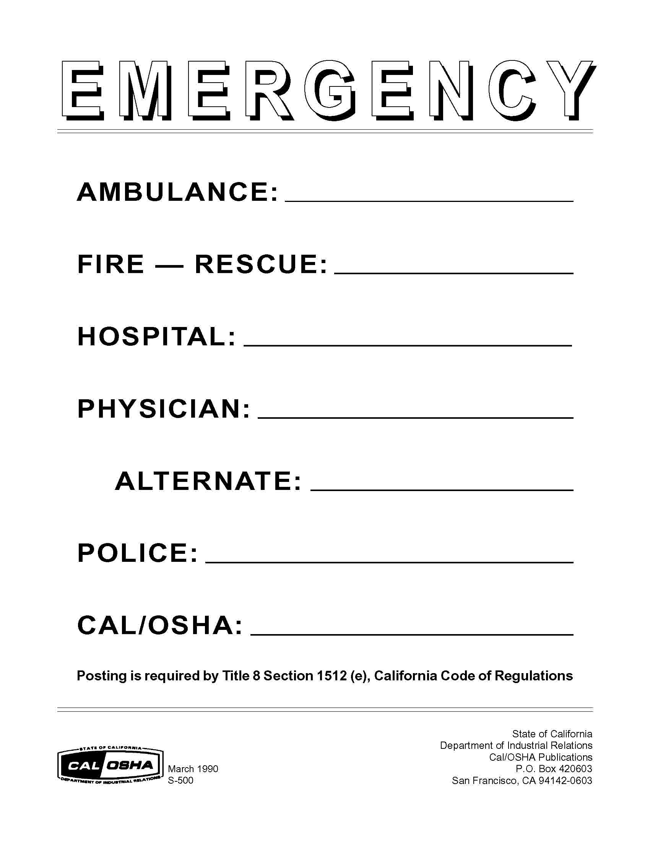

APPENDIX F

Training Record

PRINT NAME | SIGNATURE | EMPLOYEE # | DATE

_______________________________ ___________ ________________
(PRINT INSTRUCTOR’S NAME) (EMPLOYEE NUMBER) (DATE)
_______________________________
(INSTRUCTOR’S SIGNATURE)
APPENDIX G

Program Review Form

Date(s) of evaluation: ________________________

Evaluation performed by: ________________________

General Plan reviewed:
Yes No

Comments: ___________________________________________________________

Have employees been trained in their assigned/designated responsibilities?
Yes No

Comments: ___________________________________________________________

Is accumulation of flammable and combustible waste materials and residues controlled so that they do not contribute to a fire emergency?
Yes No

Comments: ___________________________________________________________

Are evacuation routes and emergency phone listings posted?
Yes No

Comments: ___________________________________________________________

Are fire extinguishers and fire suppression systems inspected regularly and maintained as required?
Yes No

Comments: ___________________________________________________________

